AGRI-AKAP: Agricultural Assistance and Knowledge Access Portal for Managing Farmers' Subsidies and Support Programs in the Municipal Agriculture Office
____________________________________

A Capstone Project
Presented to the Faculty of
College of Computing Studies, Information and Communication Technology
ISABELA STATE UNIVERSITY
Echague, Isabela
____________________________________

In Partial Fulfillment of the
Academic Requirements for the Degree
Bachelor of Science in Information Technology (BSIT)
With Specialization Track in Web and Mobile Applications Development

____________________________________

By:
Dupitas, John Mitchel M.
Iddurut, Justin R.
Ignacio, Dave Raphael M.

SEPTEMBER 2026
Table of Contents
Chapter I 1
INTRODUCTION 1
1.1 Project Context 1
Background of the Project 1
Statement of the Problem 3
1.2 Objectives of the Project 4
1.3 Scope and Limitations 5
1.4 Significance of the Project 7
Chapter II 9
REVIEW OF RELATED LITERATURE & STUDIES 9
2.1 Introduction 9
2.2 Review of Related Literature 9
2.3 Related Studies 18
2.4 Synthesis of the Reviewed Literature and Studies 27
Chapter III 30
RESEARCH METHODOLOGY 30
3.1 Research Design 30
3.2 System Development Method 31
3.3 Participants/Respondents 34
3.4 Data Gathering Instruments 36
3.5 Evaluation Procedure 37
3.6 Data Analysis Techniques 40
Chapter IV 43
TECHNICAL BACKGROUND 43
4.1 Introduction 43
4.2 System Architecture 43
4.2.1 Overview of System Architecture 43
4.2.2 System Components 43
4.2.3 System Architecture Diagram 45
4.3 Technologies and Development Tools 46
4.3.1 Programming Languages 46
4.3.2 Frontend Frameworks 46
4.3.3 Backend Framework 47
4.3.4 Database Management System 47
4.3.5 Development and Collaboration Tools 47
4.3.6 Hosting / Deployment Platform 48
4.4 Design Considerations 49
4.4.1 Scalability 49
4.4.2 Security 49
4.4.3 Usability 49
4.4.4 Performance Efficiency 49
4.5 User Interface Design (Mock-ups) 51
4.5.1 Web Application Mock-ups 51
4.5.2 Mobile Application Mock-ups 58
4.6 System Diagrams 65
4.6.1 Context Diagram 65
4.6.2 Data Flow Diagram (DFD) 66
4.6.3 Entity Relationship Diagram (ERD) 69
References: 72

Chapter I
INTRODUCTION
1.1 Project Context
The Philippine government has recognized that digital transformation is an immediate necessity rather than a future aspiration for effective public administration. The E-Governance Act (Republic Act No. 12254) made this change official in September 2025. It required all levels of government, including local government units (LGUs), to adopt digital systems. As emphasized by President Ferdinand R. Marcos Jr., digitalization is essential to providing better public service through vital frontline and back-end functions. This transition into the fourth industrial revolution requires rapid adaptation across all public sectors to ensure efficient governance and transparent service delivery.
At the local level, the Office of Municipal Agriculture (MAO) serves as the critical frontline agency responsible for executing this mandate within the agricultural sector. In partnership with the Department of Agriculture, the MAO's mission is to increase farmers' incomes and promote sustainable economic growth. To achieve its vision of prosperous rural communities and guaranteed food security, the MAO initiates vital agricultural extension programs and distributes technological packages and subsidies for rice and corn. However, fulfilling these functional statements requires highly efficient administrative mechanisms, as efficient agricultural data management is critical to ensuring timely government support.
In Echague, the Municipal Agriculture Office (MAO) manages 11,861 registered rice and corn farmers, specifically 7,763 male and 4,098 female rice and corn farmers. but struggles with inefficient, manual workflows. Currently, daily operations rely on paper forms and fragmented Excel spreadsheets, making data encoding labor-intensive and complicating cross-referencing to prevent the "double-claiming" of subsidies. Furthermore, the lack of standardized, scannable IDs hinders the efficient prioritization of vulnerable groups, such as seniors and PWDs, during physical distributions. Communication and reporting are equally constrained; staff depend on manual calculations to consolidate municipal productivity reports and rely on informal Messenger chats for critical crop damage updates, causing severe delays. Finally, without centralized historical data and predictive forecasting tools, the MAO operates on a strictly reactive basis, unable to anticipate agricultural risks or yield trends until after a harvest cycle concludes.
To resolve fragmented record-keeping and modernize workflows, the researchers propose "AGRI-AKAP: Agricultural Assistance and Knowledge Access Portal for Managing Farmers' Subsidies and Support Programs". This solution integrates a centralized administrative web dashboard for the main office and local barangay officials with an offline-capable mobile app for field staff. The platform is engineered to equip the MAO and Barangay Secretaries with comprehensive tools for tracking resource distribution, identifying farmers, monitoring production, and generating automated reports. Using the mobile interface, field technicians can easily document distribution transactions, crop stages, and verify farm damage reports during visits, ensuring vital data is captured in near real-time.
At its core, AGRI-AKAP serves as a comprehensive knowledge access portal connecting the MAO, the local government, and the farming community. By integrating Quick Response (QR) code–based identification, the system ensures fast, highly reliable retrieval of farmer profiles to transparently prevent double-claiming of subsidies. All field records seamlessly sync to a centralized web database aligned with the Registry System for Basic Sectors in Agriculture (RSBSA), utilizing Global Positioning System (GPS) coordinates to organize spatially explicit data for day-to-day decision-making. By structuring this data into a single platform, AGRI-AKAP modernizes manual workflows and transforms the MAO into a proactive, data-driven institution capable of delivering equitable agricultural support.
Statement of the Problem
The Municipal Agriculture Office (MAO) of Echague currently manages agricultural interventions for rice and corn producers through manual, paper-based reporting and fragmented agricultural registries. The municipality’s documented farming population includes 7,763 male and 4,098 female rice and corn farmers. However, the MAO lacks a centralized relational database and offline‑capable field tools to support reliable, real‑time operations. This decentralized workflow prevents field officers from verifying farmer identities at distribution points, delays timely statutory reporting, and makes it difficult to consolidate yield and distribution data quickly. The absence of integrated geospatial visualization and predictive analytics prevents the MAO from forecasting crop yields, mapping disease outbreaks, target interventions, and providing climate‑adaptive advice. Relying on informal Messenger group chats excludes vulnerable farmers who lack internet access or smartphones. This creates a critical communication gap regarding distribution schedules, disaster alerts, and localized agricultural advisories. These bottlenecks contribute to duplicate records, severe delays in data consolidation between the barangays and the main office, and an increased risk of allocation errors such as the double‑claiming of agricultural inputs. Also, without an automated verification system, field officers have a hard time systematically finding and prioritizing vulnerable groups like seniors and people with disabilities (PWDs), which often means that they have to wait in long, physically demanding lines during manual distributions. Therefore, there is a pressing need to design, develop, and evaluate a centralized web and mobile monitoring system that meets strict software quality standards to ensure efficient, reliable, and secure resource distribution.
1.2 Objectives of the Project
This project aimed to design, develop, and implement AGRI-AKAP, for the Municipal Agriculture Office (MAO) of Echague, Isabela, to improve the management of farmers’ subsidies and support programs by monitoring resource distribution, tracking crop yields, automating reports, and sending agricultural advisories via SMS.
Specifically, this project aimed to:
- Develop a centralized web-based portal that digitizes farmer records, manage subsidies and support programs and generates automated reports through an analytics dashboard.
- Integrate an offline-capable mobile application for field technicians with QR code verification and GPS-based data collection for monitoring crops.
- Implement an SMS advisory to the system that sends alerts, farming recommendations, and distribution schedules to farmers.
- Develop a module to generate farmer ID cards with unique QR codes for easy verification and identification of priority groups.
- Integrate a third-party weather API into the administrative dashboard to monitor local weather conditions and support proactive agricultural planning.
- Design and implement predictive analytics in the dashboard that provides data-driven forecasts on crop yields, and agricultural risks to support proactive planning and decision-making.
- Evaluate the system quality based on ISO/IEC 25010 standards in terms of functionality, performance, usability, reliability, and security.
1.3 Scope and Limitations
This study focuses on the design and development of AGRI-AKAP, a dual-platform digital solution intended for the Municipal Agriculture Office (MAO) of Echague, Isabela, to modernize the management of rice and corn subsidies. The Web-Based Administrative Portal serves as the central hub for administrators and Barangay Secretaries, providing tools for RSBSA-aligned database management, localized farmer profiling, field ledger encoding, GIS-based heatmap analytics, and automated statutory report generation.
Complementing this, the Mobile Application equips field technicians with an offline-capable tool for real-time QR code verification, GPS-geotagged monitoring of crop standing, and digitized tracking of seed and fertilizer distributions. To ensure social inclusivity, the system features a “Priority Access” mechanism for elderly and PWD beneficiaries via color-coded IDs and an SMS-based notification system. This allows farmers to receive localized alerts and disaster-related updates without requiring direct app access or internet connectivity, ensuring transparent and data-driven resource delivery.
A core technical inclusion in this project is the integration of a third-party weather Application Programming Interface (API). This API is programmed to continuously pull real-time meteorological metrics, specifically temperature, rainfall probability, and short-term forecasting data localized to the municipality of Echague. To address data credibility and institutional accountability requirements, the system is architected strictly as an information conduit rather than an autonomous decision-making engine. Automated climate insights generated by the API undergo a mandatory "MAO Administrative Verification" protocol. Under this workflow, local agricultural experts and designated MAO administrators must manually review and scientifically validate all weather-triggered spraying recommendations and agricultural advisories before they are authorized for SMS transmission to the farming community.
Despite its comprehensive design, the study operates within several distinct delimitations to ensure developmental feasibility. Primarily, to protect database integrity and accommodate the strict academic timeframe, the mobile application is restricted exclusively to authorized MAO field technicians. Farmers do not have direct access to the mobile app or the web portal; instead, they interact with the system passively via SMS notifications and their generated QR-coded IDs. For the initial deployment and system evaluation, the pilot testing of the mobile application will be strictly delimited to selected barangays within Echague where rice and corn are identified as the dominant agricultural commodities. Furthermore, while the mobile application supports offline data entry, real-time cloud synchronization is required to verify and prevent duplicate subsidy claims. Consequently, transactions recorded in remote areas with signal "dead spots" are queued locally and will only be fully verified against the central database once network access is restored. The project also intentionally excludes the management of other agricultural commodities, such as high-value commercial crops (HVCC) and livestock, and it does not facilitate direct financial transactions, cash subsidy distributions, or the scheduling of government-owned machinery. Finally, as the study focuses strictly on the software development lifecycle, the physical procurement or provision of hardware such as smartphones for field workers or local office servers is entirely excluded.
1.4 Significance of the Project
The proposed "AGRI-AKAP" system digitally links governmental resources to local agricultural needs. The project enhances efficiency, usability, and transparency for key stakeholders by transitioning from paper-based tracking to a centralized digital framework.
Municipal Agriculture Office and Echague Local Government Unit. Utilizing a centralized database rather than Excel spreadsheets and physical documents will enhance the efficiency of municipal administration. The automated web dashboard produces real-time productivity reports for selected barangays, facilitating data-driven decision-making, disaster risk mitigation planning, and sustainable agricultural viability. Geospatial mapping and meteorological intelligence offer visual agricultural analysis, enhancing evidence-based planning. The integrated SMS notification system rapidly disseminates government alerts during emergencies and large-scale distributions.
Barangay Secretaries. The web portal empowers local officials to seamlessly encode field ledgers and manage localized farmer masterlists. This eliminates the need to physically transport paper records to the main MAO office, ensuring that grassroots data is instantly consolidated and reducing administrative bottlenecks at the community level.
Agricultural technicians and field representatives. The mobile application replaces manual logbooks through a paperless system. Field officers may swiftly verify farmer IDs and document harvest data and disaster damage with QR codes, thereby avoiding manual entry and cross-referencing. GPS mapping improves the precision of farm location and route planning. Integrated SMS reduces communication delays between field teams and the central office.
Rice and Corn Farmers of Echague. Farmers derive the greatest advantage from transparency and resource distribution, even without direct program engagement. Localized QR codes and centralized verification mitigate double-claiming and efficient subsidy distribution. Farmers receive SMS alerts regarding subsidy timelines, meteorological conditions, and interventions without requiring internet connectivity. Precise agricultural profiling and meteorologically-informed planning mitigate crop loss.
Future IT Researchers and Capstone Proponents. This project offers academic value to the proponents by providing a crucial opportunity to apply theoretical programming knowledge to a practical, real-world issue, while also gaining hands-on experience in full-stack development and system evaluation within a formal government environment. Furthermore, this study will serve as a documented technical reference and a foundational baseline for future researchers investigating agricultural technology and digital governance within the Cagayan Valley region.

Chapter II
REVIEW OF RELATED LITERATURE & STUDIES
2.1 Introduction
This chapter establishes the theoretical foundation for "AGRI-AKAP: Agricultural Assistance and Knowledge Access Portal for Managing Farmers’ Subsidies and Support Programs." by exploring technologies required to digitize the Municipal Agriculture Office (MAO) of Echague. The review of related literature and studies first examines Digital Transformation and E-Governance in Agriculture alongside the Challenges in Agricultural Subsidy and Resource Management, particularly the risk of "double-claiming." To address these operational vulnerabilities, it explores QR Code Technology for secure, real-time validation and Hybrid Web and Mobile Architectures for offline-capable field data collection and automated administrative analytics. Finally, the chapter outlines ISO/IEC 25010, the Software Quality Framework, as the system's evaluation standard. Synthesizing these concepts establishes current technological gaps and firmly justifies the proposed hybrid solution.
2.2 Review of Related Literature
Digital Transformation in Agriculture
E-governance in agriculture is increasingly recognized as a vital tool for enhancing productivity, sustainability, and food security worldwide. According to the Association of Southeast Asian Nations (ASEAN) Leaders' Declaration (2023), digitalization has moved beyond being optional—it is now a crucial force driving agricultural resilience. To achieve this approach, governments are expected to shift toward comprehensive digital frameworks.
Translating these macro-level frameworks to local government operations requires a critical transition from manual paperwork to digital records. Basir et al. (2024) say that traditional pen-and-paper recordkeeping, while reliable in the past, is not very efficient for modern farm management and is quickly being replaced by centralized database platforms. Building on this need for digital infrastructure, Papaskiri and Lipski (2023) emphasize that establishing a digital agricultural registry is a crucial step for local governance, as it directly supports state functions related to land planning and farmer assistance. In the Philippines, the integration of such data-driven tools has proven highly effective at the local level. The International Rice Research Institute (2025) reported that digital interventions, such as the Rice Crop Manager system, successfully optimized resource allocation, providing site-specific recommendations that significantly increased farmer yields.
As these collective studies indicate, maintaining localized, fragmented records is increasingly recognized as an outdated practice that hinders rapid administrative decision-making, particularly in the context of agricultural management where timely data access is crucial for optimizing resource use and improving farmer outcomes. Specifically, as Briones et al. (2023) pointed, while digital tools are expanding across the sector, there remains a critical need for centralized government portals to bridge the digital divide and ensure interventions are transparent. Consequently, adopting an e-governance approach—such as deploying a centralized web portal—becomes a necessary operational standard for efficiently managing extensive farmer populations. By centralizing agricultural data, local government units can securely manage large-scale registries, laying the essential groundwork for transparent, data-driven governance and more effective public service delivery.
Agricultural Subsidy and Input Distribution
While centralizing agricultural data establishes the foundation for effective e-governance, the true test of this digital infrastructure lies in its practical application—most notably in the physical distribution of government resources. Agricultural subsidies act as a critical mechanism for supporting rural development and ensuring food security. According to Bhandari (2023), government-funded input subsidies are essential in helping farmers acquire necessary capital assets. In the Philippine context, the logistical burden of distributing these inputs falls heavily on local municipalities, which often struggle with inadequate resources and infrastructure to manage the distribution process effectively. Since the implementation of the Local Government Code of 1992, agricultural extension responsibilities have been devolved entirely to Local Government Units (LGUs), which historically face challenges in delivering these services due to limited local support, including insufficient funding, a shortage of trained personnel, and inadequate infrastructure for effective service delivery.
A recent study by Valdez (2024) assessing Agrarian Reform Beneficiaries in nearby Luna, Apayao, emphasizes that a farmer's rice production income is heavily dictated by their direct access to essential resources and the effectiveness of local government agricultural support policies. Because of this complexity at the local level, optimizing resource allocation requires careful planning. As Fan et al. (2023) highlight, different subsidy designs drastically affect farmer income distribution, demanding highly tailored approaches. Furthermore, Muin et al. (2025) And Zhang et al. (2025) argue that financial aid alone is insufficient; effective local governance requires comprehensive support systems and targeted, data-driven allocations to overcome these regional delivery barriers.
Despite the well-intentioned design of these programs, the actual distribution of agricultural resources presents significant logistical challenges. A major concern highlighted by BenYishay et al. (2022) is the inherent inefficiency in aid targeting, in which resources frequently fail to reach the neediest areas, leading to severe misallocation and potential leakage of benefits. This leakage is often worsened by weak administrative oversight, which can result in further inefficiencies and a lack of accountability in the distribution process, ultimately undermining the effectiveness of aid programs designed to support the neediest areas. Rahaman and Islam (2025) emphasize that strengthening transparency and targeting mechanisms with technological traceability is fundamental to preventing the risks of misallocation and unauthorized claims.
The root cause of this vulnerability often lies in the outdated methods used during the actual distribution of physical resources. Specifically, relying on manual logs and paper claim stubs traditionally serves as physical proof of receipt. However, these methods are highly prone to human error and administrative inefficiencies, which can lead to significant financial losses and hinder effective resource allocation. Reflecting on this operational flaw, Silva et al. (2022) note a crucial shift away from manual recordkeeping toward digital systems to improve accuracy in human and resource management. Managing large volumes of unstructured, manual data creates severe bottlenecks, a problem that researchers like Ozonze et al. (2023) have observed in other data-heavy domains, necessitating automated data quality tools. Ultimately, these documented challenges prove that the risk of resource leakage and allocation errors cannot be addressed through manual consolidation alone; it requires a secure, real-time digital verification system at the point of distribution.
QR Code Technology for Validation
Alsuhibany (2025) develops an innovative Quick Response (QR) code system for tamper‑proof generation and fraud‑resistant verification using digital watermarking and a neural‑network–based authentication model. Security features are embedded within the QR symbol itself, and experiments on 5,000 samples show high accuracy in distinguishing genuine from fraudulent codes. This demonstrates how QR code design alone can provide strong integrity checks, informing Agri‑AKAP's use of securely generated QR labels for farmer and parcel identification.
Wang et al. (2024) propose a dual‑code agricultural traceability system in which product information is encrypted into QR codes using the RSA algorithm. The system supports end-to-end management and monitoring of production, processing, and logistics, while enabling consumers to verify authenticity by scanning an encrypted QR code. This aligns with AGRI-AKAP's goal of encoding key beneficiary and transaction data into QR codes that can be scanned during field visits or during payout processing.
Yang et al. (2022) analyze consumer intentions to scan QR codes on eggs in Taiwan's traceability program, finding that production certificates and inspection information are the main motivators and that QR labels serve as an effective bridge between producers, regulators, and consumers. These insights suggest that Agri‑AKAP's QR codes should act as internal identifiers and expose clear, trust‑building information when scanned by field staff or farmers.
Collectively, these studies show that QR codes can function as secure, low-cost carriers of unique identifiers and verification data on their own, supporting AGRI-AKAP's goal of reducing the incidence of 'double-claiming' and on-site validation workflows.
Hybrid Web/Mobile Architectures and Offline Field Data Collection
Potturu (2023) presents an offline‑capable field data system using Microsoft PowerApps and Robotic Process Automation (RPA) for rural farms with limited connectivity. Data are captured on mobile devices offline, stored locally, and synchronized with a central database when connectivity returns, while RPA automates back‑office integration (Potturu, 2023). The study reports preserved data integrity, smooth synchronization, and improved user experience, offering a strong architectural pattern for Agri‑AKAP’s field modules.
Sciullo et al. (2023) propose a hybrid push‑pull architecture for mobile crowdsensing using the Web of Things, standardizing device interactions and enabling both push and pull data flows in an Android Mobile Computing System (MCS) app. Simulations show greater flexibility for campaign designers compared with purely push or pull options. This concept, when applied to AGRI-AKAP, involves field officers proactively uploading data (push) and central servers requesting synchronizations or verifications as needed (pull).
González-Pérez et al. (2023) introduce awareness-raising with an additional reactive networked systems (AwarNS) framework. This modular, context-aware mobile architecture supports passive/active data sampling, on‑device and server‑side analysis, and offline/online interventions while emphasizing reliability, power efficiency, privacy, and testability. Although focused on mobile health, its sense–analyze–act paradigm is directly relevant to Agri‑AKAP’s need to collect field data, perform local validations, and trigger context-aware actions (e.g., verification alerts) even in constrained environments.
Collectively, these works show that effective rural systems must support robust offline operation, delayed synchronization, and modular analytics, all of which can guide Agri‑AKAP’s hybrid web–mobile design.
Agro-Climatic Intelligence and Decision Support Systems
The integration of localized weather data is a crucial step toward proactive agricultural management. Weather APIs serve as real-time data conduits linking meteorological forecasts to agricultural decision support systems (DSS), enabling dynamic crop recommendations and risk alerts across diverse farming contexts. Smart farming architectures increasingly integrate this real-time meteorological data from APIs to support adaptive crop management decisions, translating raw metrics into actionable agronomic insights. For example, real-time weather data combined with predictive modeling enables pest and disease prevention strategies by using weather-driven decision tree models. However, integrating these automated insights into local governance requires careful oversight. To ensure credibility and mitigate the risks of inaccurate automated forecasting, the raw algorithmic data must be manually validated by regional agricultural experts before field implementation. This "Administrative Verification" grounds the technology in verified agronomic science, ensuring the municipality only disseminates safe and accurate recommendations.

SMS-Based Extension Services for Climate-Adaptive Farming
While centralized web dashboards provide macro-level intelligence for administrators, delivering this information to farmers in rural areas requires highly accessible communication channels. Research consistently highlights Short Message Service (SMS) as a robust, cost-effective technology to bridge the digital divide for small-scale producers because it functions reliably without requiring smartphones or internet connectivity. E-governance initiatives actively leverage SMS and mobile-based public services to enhance accessibility, efficiency, and transparency for rural farmers. Furthermore, SMS-based weather advisory services deliver real-time, localized meteorological guidance that significantly improves farm operational decisions and reduces input costs. For instance, field studies demonstrate that weekly forecast-based advisories delivered via text SMS significantly reduced fertilizer and seed application rates, leading to substantial cost savings per acre. By systematically integrating weather APIs into SMS broadcast platforms, local government units can transition from reactive disaster reporting to proactive agricultural extension, ensuring that critical, expert-verified interventions reach vulnerable farmers immediately.
ISO/IEC 25010 Software Quality Framework
The International Organization for Standardization/International Electrotechnical Commission (ISO/IEC) 25010 Software Quality Framework serves as a comprehensive standard for evaluating application performance and user satisfaction. Research consistently highlights that adherence to this framework strongly dictates overall software success. A study by Moumane et al. (2024) demonstrates that functional suitability is a primary driver that shapes operability, performance efficiency, reliability, and security, suggesting that these characteristics must be explicitly embedded throughout the development lifecycle. Similarly, Jung et al. (2025) emphasize that while functional suitability and usability are the most salient characteristics for end users, underlying metrics such as security and maintainability remain critical for fostering user trust. This means that developing AGRI-AKAP requires a strong focus on precise eligibility logic and reliable performance, along with an intuitive interface tailored for field users who are not experts.
Following these ISO standards is vital for systems functioning within the public sector. Purbaratri et al. (2023) stress that high-quality, secure, and well-maintained applications are foundational for smart-government frameworks, reinforcing ISO/IEC 25010 as the ideal guiding standard for e-governance platforms operating in the agricultural domain. Furthermore, structured testing against these specific metrics provides a clear roadmap for iterative system refinement. As illustrated by Suryadi and Sulistiyani (2024) in their multi-metric software assessment, rigorously evaluating characteristics such as functional suitability, performance efficiency, usability, reliability, and security allows developers to identify specific vulnerabilities and drastically improve user-perceived quality. Ultimately, utilizing ISO/IEC 25010 as AGRI-AKAP’s evaluation backbone ensures the system can be methodically tested and refined to meet the strict operational demands of a municipal registry.

2.3 Related Studies
Development of a Database Management System for a Municipal Agriculture Office in the Philippines
A local study by Mappatao et al. (2025) focused on the development of a tailored Database Management System (DBMS) for the Municipal Agriculture Office of Peñablanca, Cagayan. Similar to the operational challenges in Echague, the researchers identified that the MAO's reliance on a manual Registry System for Basic Sectors in Agriculture (RSBSA) caused severe delays in registration and inaccurate records. By implementing a user-friendly DBMS, the study successfully streamlined administrative workflows, notably reducing farmer registration time from fifteen minutes to just five minutes, and cutting beneficiary list validation from six hours down to mere seconds. Furthermore, their usability testing yielded a high Single Usability Metric (SUM) score of 86.19%, proving that transitioning an LGU to a digital platform significantly increases operational efficiency.
However, while the DBMS developed by Mappatao et al. (2025) successfully optimized office-based data management, it presents a critical functional limitation: it operates strictly as a centralized database and lacks a dedicated mobile platform for on-site field technicians. Consequently, while the system can generate beneficiary lists quickly in the office, it does not provide field officers with the necessary offline-capable tools or QR-based verification methods to secure the actual physical distribution of resources in remote barangays. This gap highlights the necessity for a hybrid architecture that extends the power of a centralized web database directly into the field via a mobile application.
Development of a multi scale interactive web-GIS system to monitor farming practices: a case study in Lemnos Island, Greece
Avanidou et al. (2023) developed "FarmGeoBalance," an interactive web Geographic Information System (GIS) designed to systematically record and monitor farming practices to assess their impact on natural resources and biodiversity. The web map application communicates with a GeoDatabase, allowing standardized and visualized spatial and non-spatial agricultural data—such as fertilization, plant protection, and irrigation—to be displayed at both the field and farm levels.
The researchers employed a case study methodology applied to an extensive arable farming system on Lemnos Island, Greece, deploying the system across 12 producers and 678 fields during the 2020–2022 cultivation periods. Key findings revealed that capturing precise geographic data, combined with daily agricultural practices, facilitates the assessment of environmental effects across various scales. The study also concluded that the active participation of end-users is a key component of the system's effectiveness.
However, a significant limitation of this system is that it requires farmers to import, store, and revise their everyday and seasonal practices directly in the web application. In municipalities like Echague, relying on local farmers' digital literacy and their access to consistent internet to maintain complex GIS logs creates a severe bottleneck. The proposed system eliminates the need for farmers to navigate digital maps or encode data themselves. Instead, trained Municipal Agriculture Office (MAO) field technicians, equipped with offline mobile apps, take on the entire operational burden. By using simple printed QR codes for farmer identification, AGRI-AKAP guarantees accurate, geo-tagged field reports without necessitating any technological interaction from farmers.
Digitalisation in agriculture: A scoping review of technologies in practice, challenges, and opportunities for smallholder farmers in sub-saharan africa
Choruma et al. (2024) conducted a scoping review examining the transformative impact of digitalization in agriculture, specifically focusing on the technologies, challenges, and opportunities available to smallholder farmers. The research explored the current utilization of digital tools, such as digital extension services and the digital marketing of agricultural products, to uplift rural livelihoods. The researchers utilized a systematic literature review methodology, examining 27 relevant studies to identify regional technological trends and adoption impediments.
The major findings indicated that digitalization significantly improves farmers' access to information and markets, enhances overall productivity, and provides critical opportunities for better data-driven decision-making. The study identified significant challenges that prevent widespread adoption, including poor internet access, underdeveloped rural infrastructure, high costs, and limited digital skills among many smallholder farmers. This study highlights a critical gap: systems that require farmers themselves to operate complex apps often fail. The proposed system directly resolves this infrastructural limitation in Echague by deploying an offline-first mobile application exclusively to trained MAO field officers. Furthermore, by using simple printed QR codes (Quick Response codes) for farmer identification, the system requires no digital literacy or smartphone ownership on the part of the farmers, thereby efficiently bridging the digital divide.
The Impact of the Digitalization System for Subsidized Fertilizer Distribution on the Productivity of Rice Farmers in Malang Regency
Waluyo et al. (2025) investigated the impact of digitalizing a subsidized fertilizer distribution system on rice farmers' overall productivity in Malang Regency. The research focused on understanding whether transitioning to a digital distribution model directly improved agricultural output or if other mediating factors were necessary for success. The study employed a survey and data analysis methodology, surveying a large sample of 484 rice farmers across 33 subdistricts between August and November 2024.
The major findings revealed a crucial insight: digitalization itself does not have a significant direct impact on rice productivity. Instead, the study found that digitalization has a strong positive effect on farmer satisfaction and technology accessibility, which, in turn, act as significant "mediating roles" that ultimately lead to increased productivity. The researchers concluded that the success of digital fertilizer distribution depends entirely on highly responsive services and the optimized involvement of agricultural extension workers. A key limitation of the studied system is that its success is constrained when technology access is limited or when field workers are not properly equipped to assist farmers. The proposed system directly addresses this limitation by actively empowering the MAO's agricultural extension workers through an offline-capable mobile application. By placing the technology in the hands of trained technicians rather than forcing farmers to navigate complex apps, AGRI-AKAP guarantees responsive service, maximizes technology accessibility through simple printed QR codes, and ensures the successful, transparent distribution of subsidized inputs.
Impact of SMS-Based Agricultural Information Systems on Crop Management Skills
Ameh et al. (2025) conducted a quasi-experimental study on the effectiveness of SMS alerts in educating farmers on pest control and fertilizer application in South-Eastern Nigeria. The researchers observed that SMS interventions increased farmers' technical knowledge by 36.8%. However, the study highlighted a critical gap: the system primarily functioned as a one-way communication tool and was rarely integrated into participatory extension models, resulting in inconsistent implementation rates on the farm. AGRI-AKAP addresses this issue by utilizing SMS as a logistical bridge between the central office and field technicians; rather than just sending generic advice, the system uses automated SMS to coordinate physical distribution schedules and subsidy pickup alerts, ensuring that on-the-ground extension activities directly support digital information.
Blockchain-Enabled Traceability in the Rice Supply Chain: Insights from the TRACE-RICE Project
Gonçalves et al. (2025) developed a blockchain-enabled traceability system for the Mediterranean rice supply chain as part of the TRACE-RICE pilot project in Portugal. The system used a "Rice Field Data Recording App" built with ArcGIS Survey123 to digitize agronomic compliance records, linking these field records to blockchain-verified Quick Response (QR) codes affixed directly to consumer packaging.
The researchers employed a pilot testing methodology, deploying the system across different production contexts during the 2023 and 2024 rice harvests to monitor field recording processes and track consumer engagement. The major findings demonstrated that the system significantly enhanced data consistency, streamlined field recording, and improved agricultural transparency, successfully registering 174 interactions with consumer QR codes that provided valuable business analytics.
However, a key limitation of this study is its heavy focus on consumer-end commercial traceability—tracking the final harvested rice to retail buyers using a complex blockchain infrastructure. In contrast, the proposed system focuses on the very beginning of the agricultural cycle for local government governance. Instead of tracking retail products for consumers, AGRI-AKAP uses a straightforward, cost-effective relational database to transparently track the distribution of raw, subsidized inputs (seeds and fertilizers) from the Municipal Agriculture Office directly to farmers, preventing subsidy duplication without the overhead of blockchain technology.
Optimizing Web-based Inventory Management system using QR code Technology
Balaji et al. (2024) developed a pioneering web-based inventory management system that leverages Quick Response (QR) codes to revolutionize traditional inventory tracking methods. The system was designed to facilitate seamless data retrieval, dynamic updates, and visualization, introducing an innovative approach to rapid data entry and reliable tracking across diverse industries.
The researchers used a web development method to build the system's architecture with PHP and JavaScript. They then used quantitative case studies to see how well it worked. The major findings underscore the system's remarkable impact on operational efficiency, showcasing an impressive retrieval speed of 25 seconds, an overall efficiency improvement of 81%, and a significant reduction in manual error rate to 4.5%.
However, a limitation of this forward-thinking solution is its reliance on a purely web-based architecture, which assumes constant internet connectivity—a standard condition in indoor warehouses or retail environments but highly impractical for outdoor agricultural operations. The proposed system takes this proven, error-resistant Quick Response (QR) inventory concept and specifically adapts it for the rural government sector. By incorporating an offline-capable mobile application alongside the web database, AGRI-AKAP ensures that MAO field officers can successfully distribute and track agricultural "inventory" (seeds and fertilizers) directly in remote barangays, regardless of internet availability.
Raks. SK v1.0 - A Secure and Trackable QR Framework with Embedded Metadata and Real-Time Validation
Kumar et al. (2025) proposed "Raks. SK v1.0," a comprehensive, secure, and trackable Quick Response (QR) code framework designed to address critical challenges regarding data security, authenticity, and traceability in digital workflows. The system works by embedding AES-256-encrypted metadata directly into QR codes, enabling strict access control and end-to-end event tracking for various data types, including URLs, location links, and static text.
The study employed a system development methodology focused on cryptography and network identity tracking. Each generated QR code is securely encrypted and dynamically tagged with the scanning device's MAC address and real-time geolocation coordinates. Upon scanning, the system decrypts the payload and concurrently records the scan time, device MAC address, and geolocation in a secure relational database. The main findings showed that the architecture delivers highly scalable, low-latency processing and strong encryption throughput, making it very effective against spoofing attacks, payload tampering, and unauthorized access within digital governance.
However, a significant limitation of this framework is its strict reliance on capturing real-time geolocation coordinates and executing concurrent database validation during the exact moment of the scan. In rural agricultural environments, such as the remote barangays of Echague, frequent signal "dead spots" make real-time database tracking impossible. The proposed system directly addresses this infrastructure limitation by implementing an offline-capable mobile application. Instead of failing when the network drops, AGRI-AKAP securely queues the scanned QR transactions locally on the field officer's device, ensuring continuous operation and syncing with the central database only when network access is restored.
Innovative QR Code System for Tamper-Proof Generation and Fraud-Resistant Verification
Alsuhibany (2025) developed a cutting-edge solution to generate and validate Quick Response (QR) secure codes to prevent barcode substitution fraud in retail and wholesale environments. The system used a digital watermarking technique to embed invisible, tamper-resistant information directly into the visual pattern of the QR code, along with a neural network-based authentication model to verify the legitimacy of scanned codes without querying an external database.
The study employed an experimental methodology, training a Convolutional Neural Network (CNN) object detection classifier on a dataset of 5,000 QR code samples. These samples were subjected to various real-world distortions, including Gaussian noise, blur, and skewed camera angles. The major findings demonstrated that integrating visual watermarking and AI achieved a high classification accuracy of 97.2%, effectively and dynamically distinguishing genuine from fraudulently reprinted QR codes.
However, a notable limitation of this system is its heavy reliance on complex, AI-driven image processing. The study noted that this complexity led to slower decoding speeds and required commercial reader Software Development Kits (SDKs) that demand significant computational power, making it cumbersome for basic mobile devices. The proposed system addresses this limitation by avoiding heavy on-device image processing; instead, it utilizes standard, lightweight QR codes that serve as mathematically unique keys directly linked to a centralized, relational database (RSBSA). This ensures that MAO field officers can conduct instant, offline-capable verification using basic, low-end smartphones without any computational lag.
Smart Educational Resource Management: A QR Code-Enabled System with Notification and Alerting Capabilities
Teves (2024) developed a novel QR Code-Enabled Educational Resource Management System designed to track the availability, location, and usage history of resources such as textbooks and equipment. The system allows students and teachers to scan QR codes on mobile devices and features automated alerting to remind users of resource due dates or changes in availability.
To assess the system's effectiveness, the researcher employed a software evaluation methodology based strictly on the ISO/IEC 25010 Software Quality Characteristics Framework, measuring factors such as functional suitability, performance efficiency, usability, reliability, and security. The major findings demonstrated that the QR-code system achieved exceptionally high levels of quality in use, proving that mobile-scanned QR technology effectively streamlines manual tracking processes and eliminates delays in resource management.
While highly successful, this system has the limitation that it was designed strictly for an indoor, controlled academic environment to track static, reusable assets (such as books and hardware). It does not account for the complexities of distributing state-funded, consumable resources outdoors, including varying environmental conditions, logistical challenges, and the need for real-time data tracking in less controlled settings. The proposed system adapts this exact, highly effective QR-code tracking mechanism to a dynamic agricultural setting to manage the distribution of consumable subsidies (seeds and fertilizers). Furthermore, AGRI-AKAP directly adopts Teves' (2024) proven methodology by utilizing the same ISO/IEC 25010 software quality standards to evaluate its own functional suitability, performance efficiency, usability, reliability, and security in a government workflow.
2.4 Synthesis of the Reviewed Literature and Studies
The reviewed literature and studies provide an in-depth overview of the theoretical and technological foundations for modernizing agricultural management and resource distribution. The reviewed materials focus on the shift toward digital transformation and e-governance in agriculture. They also examine how the Philippines is using technology to speed up municipal office registration. Alongside these digital shifts, the literature examines the logistical challenges of subsidy allocations, particularly the risk of resource leakage and "double-claiming". To address these operational vulnerabilities, researchers examine the integration of Quick Response (QR) code technology for secure validation, the implementation of hybrid web and mobile architectures for offline data collection, the deployment of SMS systems for informational alerts (Ameh & Emmanuel, 2025), and the rigorous adherence to the ISO/IEC 25010 framework for assessing software quality in public sector systems.
A significant similarity among the examined research studies is the consensus that traditional, manual recordkeeping is ineffective and must be replaced by centralized digital systems to ensure data integrity and transparency. Studies agree that relying on physical logbooks creates severe administrative bottlenecks and increases the likelihood of human error or misallocation. By digitizing these records, studies have demonstrated significant efficiency gains, such as reducing farmer registration time from fifteen minutes to just five. Furthermore, researchers consistently highlight that incorporating automated identification technologies, such as QR codes, significantly enhances rapid data entry, reduces error rates, and serves as a reliable mechanism to prevent fraud. Across various applications—from health services to educational resource management—the literature also similarly emphasizes that rigorously evaluating these digital systems using the ISO/IEC 25010 standard is critical to ensuring functional suitability, reliability, and end-user trust.
Reflecting the approach of earlier studies, the proposed "AGRI-AKAP" system intends to modernize a paper-based workflow by creating a streamlined, centralized digital environment. Like the systems evaluated by Papaskiri and Lipski (2023) and the International Rice Research Institute (2025), AGRI-AKAP aims to establish a data-driven agricultural registry to optimize resource allocation and support local governance. Furthermore, much like the web-based inventory and educational tracking systems reviewed, the proposed study heavily leverages QR codes as internal identifiers to facilitate rapid data retrieval and automate distribution tracking. AGRI-AKAP also mirrors hybrid push-pull architectures and offline data-collection methodologies to ensure field officers can collect and synchronize data effectively.
Despite these shared objectives, existing studies reveal critical functional gaps that the proposed system aims to address. While current office-based database systems successfully optimize data management, they often lack the dedicated mobile platforms required for on-site field technicians. Additionally, many informational tools either depend entirely on the internet or function solely as one-way communication channels (Ameh & Emmanuel, 2025). AGRI-AKAP diverges from these models by extending centralized database power directly into the field via an offline-capable mobile application. By transforming SMS alerts into a coordinated logistical bridge for distribution, the system provides a context-aware solution tailored specifically for the rural realities of Echague.

Chapter III
RESEARCH METHODOLOGY
3.1 Research Design
This study employed a Developmental Research Design, for projects requiring a comprehensive understanding of existing manual processes prior to the formulation of a structured digital solution. Mahat et al. (2024) provide a clear explanation of developmental research design as a systematic approach that supports iterative analysis and evaluation to ensure credibility and validity in research. As supported by Aris (2024), this approach emphasizes expert consensus and multiple phases including needs assessment, design, development, implementation, and evaluation to create effective educational or technological tools.
In line with these principles, the proponents will develop AGRI-AKAP: Agricultural Assistance and Knowledge Access Portal for the management of farmers' subsidies and support programs. To ensure continuous responsiveness to stakeholder feedback, the proponents will be using Rapid Application Development (RAD) methodology. The project began with an analysis phase, utilizing structured interviews and document reviews of existing manual logbooks and intake forms. This will allow the researchers to pinpoint inefficiencies, including duplicate data and the potential for double-claiming.
Following the analysis, the proponents underwent design and development phases to convert the system architecture and workflows into a functional prototype. Finally, the evaluation phase will systematically assess the proposed system according to the ISO/IEC 25010 software quality model. To ensure rigorous and scoped testing, the evaluation will be divided among specific respondent groups: IT experts will evaluate complex technical dimensions, while Municipal Agriculture Office (MAO) administrators and field technicians will assess user-centric characteristics, focusing on functional suitability, performance efficiency, and usability. Through these iterative stages, the study seeks to develop a robust, contextually relevant system concept that meets the operational requirements of the MAO.
3.2 System Development Method
Figure 1
Rapid Application Development (RAD) Methodology
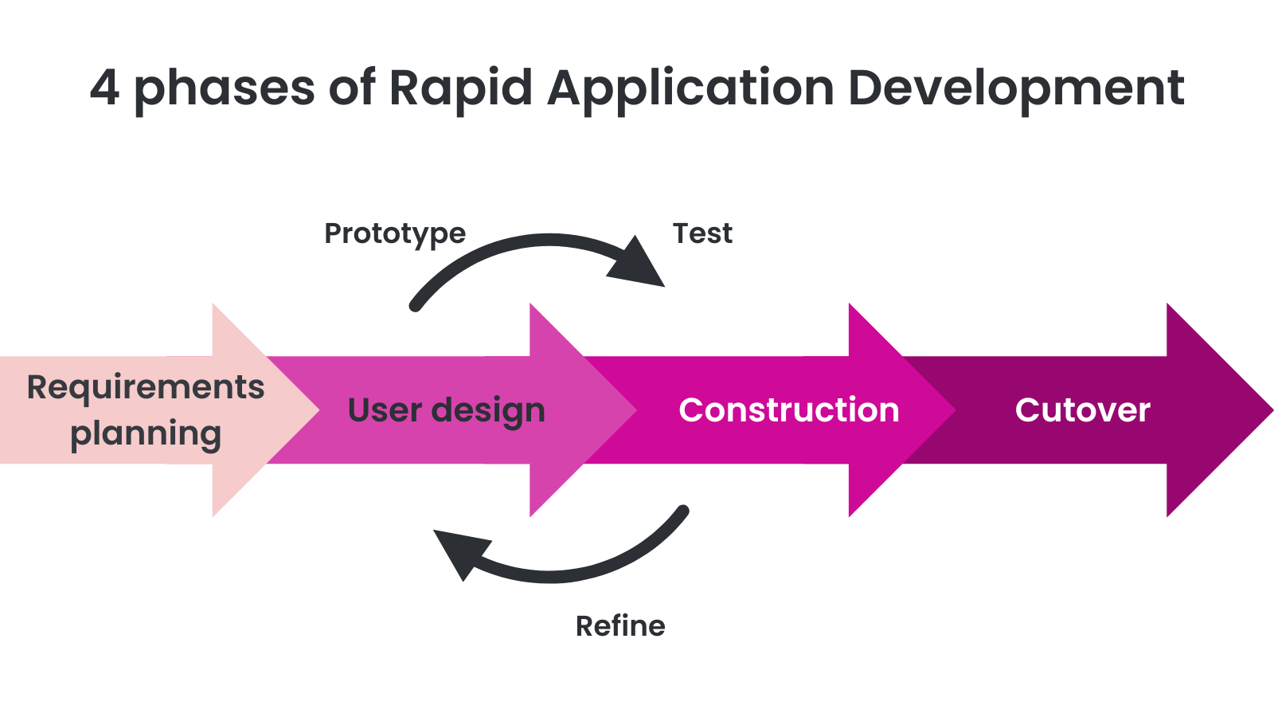
The development of the AGRI-AKAP portal adopted the Rapid Application Development (RAD) as its foundational methodology. As conceptualized by Crelin (2022), RAD is an iterative software development framework that prioritizes the creation of functional prototypes and continuous stakeholder feedback over conventional, elongated development and testing cycles. This methodology was strategically selected for its inherent flexibility, which allows the system to evolve in response to real-time user evaluations. By facilitating a cyclical process of refinement, the RAD model ensures that the final technical solution is highly aligned with the specific operational requirements of the end-users. This methodology is particularly appropriate for government office environments where operational requirements frequently evolve and practical, user-centered solutions are essential.
System development follows a structured four-phase RAD cycle consisting of Requirements Planning, User Design, Construction, and Cutover. Responsibilities are distributed among the project members to ensure systematic task allocation and consistent development progress.
During the Requirements Planning phase, the project team collaborated with personnel from the Municipal Agriculture Office (MAO) to identify workflow inefficiencies, examine existing operational procedures, and define clear and measurable system objectives. Priority was given to essential safeguards, particularly mechanisms designed to prevent subsidy double-claiming, ensuring that the system aligned with official agricultural assistance policies and regulatory procedures.Figure 25
The User Design phase emphasized collaborative and iterative prototyping. Developers and MAO personnel participated in consultation sessions to create and refine system prototypes. Interface drafts, wireframes, and mock-up models were developed to present the proposed designs of the web dashboard and mobile application. These prototypes underwent multiple cycles of evaluation and revision based on stakeholder feedback to improve usability, maintain workflow clarity, and ensure compatibility with actual field operations. Critical operational components, including QR code scanning procedures and offline data queuing mechanisms, were progressively refined during this stage to guarantee a secure, "human-in-the-loop" workflow.
Subsequently, the Construction phase focused on converting approved prototypes into a fully operational system. Rapid coding and module integration were performed to develop complete system components. Major development activities included establishing the centralized database, implementing QR code scanning functionalities, and developing reliable offline data synchronization processes. System features were produced in modular increments to facilitate efficient testing, timely revisions, and continuous performance improvement.
The final stage, the Cutover phase, will involve comprehensive system validation, pilot implementation, and full operational deployment. The first Minimum Viable Product (MVP) will be deployed in selected pilot barangays in Echague for actual field use. This phase will include user training, live operational testing, data migration, and final system refinements based on stakeholder feedback and observed system performance.
A central strength of the RAD framework is sustained stakeholder engagement throughout the development process. Continuous participation of Municipal Agriculture Office personnel in prototype assessments ensures that system interfaces, workflow structures, and offline processing capabilities accurately reflect real operational conditions rather than being based solely on technical assumptions.
Overall, the Rapid Application Development methodology supports the delivery of a functional, reliable, and user-centered AGRI-AKAP system through structured prototyping, continuous evaluation, and collaborative stakeholder involvement.
3.3 Participants/Respondents
This study will survey Echague's Municipal Agriculture Office (MAO) agricultural technicians and office workers who manage farmer data and generate monitoring reports. The proponents will select participants using Purposive Sampling. This non-probability sampling method is valid since the respondents have the expertise to evaluate the manual monitoring process and identify the operational constraints the new system must address. Due to the specialized nature of these roles, the sample will include approved MAO workers stationed in Echague during the assessment period and external technical evaluators.
Table 1
Distribution of Respondents
Respondent Group | Role | Number
IT Experts | Provide technical insights on system design, development, and feasibility of the proposed portal. | 5
Barangay Secretary | Detail procedures for farmer registration, the encoding of local planting ledgers, and community reporting requirements. | 5
MAO Administrators | Offer information on current processes, policies, and management of agricultural programs and subsidies. | 10
Field Technicians | Share on-ground experiences in assisting  farmers and using agricultural support systems. | 10
Total |  | 30
A total sample size of 30 respondents, divided into IT experts (5), Barangay secretaries (5), MAO administrators (10), and field technicians (10), aligns with practices in specialized user group evaluations where purposive sampling targets relevant stakeholders. According to White (2022), while validation studies of quantitative instruments often show wide variation, many practical studies use samples of 20-50 participants to balance depth and feasibility. Furthermore, Barletta et al. (2022) note that including a small group of expert reviewers, such as the five IT experts in this study, is consistent with approaches that incorporate technical validation alongside user feedback to ensure a comprehensive quality assessment. Finally, as emphasized by both White (2022) and Surachman (2024), stratifying users into distinct cohorts, such as administrators, field technicians, and Barangay secretaries, enhances the representativeness of different user experiences within a limited sample. Overall, 30 participants are justified for an ISO 25010 evaluation in a specialized organizational context.
A significant methodological limitation of this study is the exclusion of farmers from the software evaluation cohort. Farmers only function as holders of supplied QR codes and do not engage with or operate the AGRI-AKAP software; thus, submitting them to software evaluation tools would fundamentally compromise the integrity of the research data. Consequently, the assessment will be exclusively limited to the designated MAO personnel and IT experts.
3.4 Data Gathering Instruments
To ensure the reliability and validity of the data gathered, the proponents utilized a triangulation method that integrated both qualitative and quantitative data collection devices during the requirements analysis phase. This methodological approach facilitated cross-validation of data from multiple sources, thereby enhancing the trustworthiness of the findings.
Stakeholder consultation was primarily executed via structured interviews with personnel from the Municipal Agriculture Office (MAO) to obtain qualitative data on current farmer monitoring procedures, benefit distribution processes, and challenges associated with the existing manual system, including verification delays and data redundancy. The interviews served as a first phase of requirements gathering, enabling the proponents to understand the precise system needs and expectations of the office. A thorough document review was conducted to complement and validate the material gathered from interviews, involving a critical analysis of current agricultural monitoring forms, farmer records, office reports, paper-based registries, RSBSA intake forms, and manual distribution logbooks.
The process ensured that the proposed system architecture was based on actual operational records rather than solely on verbal reports, while also aiding in identifying critical data items for the database schema and enabling objective mapping of existing operations. A feasibility study checklist was employed as a quantitative tool to assess the proposed system across critical dimensions: technical, operational, economic, and schedule feasibility, ensuring a thorough evaluation of the system's practicality and readiness for implementation within the organizational framework.
3.5 Evaluation Procedure
The evaluation procedure in this study bridges the current feasibility assessment with the strict software testing protocols planned for the future development phase.
The ISO/IEC 25010 Software and Data Quality Questionnaire will be employed to assess end users' perceptions of software quality, with particular emphasis on functionality suitability,reliability, performance efficiency, usability, and security. Estdale and Georgiadou (2018) leveraged ISO/IEC 25010, recognized as a leading quality model, to critically analyze its applicability and completeness in evaluating software products throughout their lifecycle as digital services delivered to customers. They further noted that ISO/IEC 25010 serves as a primary framework for assessing software products, supporting improvements in software process performance, and identifying areas for improvement.
The designated respondents will assess the system based on their assigned ISO/IEC 25010 characteristics and respective sub-characteristics, which include:
1. Functional Suitability - the degree to which a product or a system provides a function that meets stated and implied needs when used under specified conditions. This characteristic is composed of the following sub-characteristics:
- Functional completeness - Degree to which the set of functions covers all the specified tasks and intended users' objectives.
- Functional correctness - Degree to which a product or system provides accurate results when used by intended users.
- Functional appropriateness - Degree to which the functions facilitate the accomplishment of specified tasks and objectives.
2. Performance Efficiency - the degree to which a product performs its functions within specified time and throughput parameters and is efficient in the use of resources (such as CPU, memory, storage, network devices, energy, materials, etc.) under specified conditions. This characteristic is composed of the following sub-characteristics:
- Time behavior - Degree to which the response time and throughput rates of a product or system, when performing its functions, meet requirements.
- Resource utilization - Degree to which the amounts and types of resources used by a product or system, when performing its functions, meet requirements.
- Capacity - Degree to which the maximum limits of a product or system parameter meet requirements.
3. Usability - Degree to which specified users can use a product or system to achieve specific goals with effectiveness, efficiency, and satisfaction in a specified context of use. This characteristic is composed of the following sub-characteristics:
- Appropriateness recognizability - Degree to which users can recognize whether a system is appropriate for their needs.
- Learnability - Degree to which specified users can use a system to achieve specific goals of learning to use the product or system with effectiveness, efficiency, freedom from risk, and satisfaction in a specified context of use.
- Operability - Degree to which a system has attributes that make it easy to operate and control.
- User error protection - The degree to which a system protects users against making errors.
- User interface aesthetics - Degree to which a user interface enables pleasing and satisfying interaction for the user.
- Accessibility - Degree to which a system can be used by people with the widest range of characteristics and capabilities to achieve a specified goal in a specified context of use.
4. Reliability - Degree to which a system, product, or component performs specific functions under specified conditions for a specified period of time. This characteristic is composed of the following sub-characteristics:
- Maturity - Degree to which a system or component meets needs for reliability under normal operation.
- Availability - Degree to which a system or component is operational and accessible when required for use.
- Fault tolerance - Degree to which a system or component operates as intended despite the presence of hardware or software faults.
- Recoverability - Degree to which, in the event of an interruption or a failure, the system can recover the data directly affected and re-establish the desired state of the system.
5. Security - Degree to which a product or system protects information and data so that persons or other products or systems have the degree of data access appropriate to their types and levels of authorization. This characteristic is composed of the following sub-characteristics:
- Confidentiality - Degree to which a system ensures that data are accessible only to those authorized to have access.
- Integrity - Degree to which a system component prevents unauthorized access to, or modification of, computer programs or data.
- Non-repudiation - The degree to which actions or events can be proven to have taken place so that the events or actions cannot be repudiated later.
- Accountability - The degree to which the actions of an entity can be traced uniquely to the entity.
- Authenticity - Degree to which the identity of a subject or resource can be proved to be the one claimed.
3.6 Data Analysis Techniques
The analysis phase data was analyzed using qualitative and descriptive statistics. Proponents will use Content Analysis for qualitative interview data. Interview transcripts were evaluated to identify operational constraints like data fragmentation. Classifying these concerns into problem categories and mapping them to actionable system needs will follow. This technique assures that the system's technical characteristics are justified by stakeholder concerns, linking recorded problems to proposed solutions. Descriptive statistics will be used to examine feasibility checklist findings for quantitative data to prove project feasibility.
For the future evaluation phase, the data analysis will strictly adhere to the dual-tiered assessment strategy. Survey data collected from the IT Experts regarding all five targeted ISO/IEC 25010 characteristics (Functional Suitability, Performance Efficiency, Usability, Reliability, and Security) will be tabulated and analyzed independently. Conversely, the data collected from the MAO administrators and field technicians will be analyzed solely for the three user-centric characteristics they evaluate (Functional Suitability, Performance Efficiency, and Usability). This distinct segregation ensures that complex technical evaluations are not diluted or skewed by end-user metrics.
For the future evaluation phase, A 4-point Likert Scale will be utilized for each criterion to quantify users' perceptions, which will allow respondents to rate the software quality as follows:
Table 2
4-point Likert Scale
Numerical Rating | Mean Range | Descriptive Rating
4 | 3.26 – 4. 00 | Strongly Agree
3 | 2.51 - 3.25 | Agree
2 | 1.76 – 2.5 | Disagree
1 | 1.00 – 1.75 | Strongly Disagree

A 4-point Likert scale will be utilized to evaluate the system that will be developed, offering a rigorous and meaningful assessment of user perceptions. By intentionally eliminating the neutral midpoint option, this structure requires respondents to provide a definitive evaluative judgment. As Alqoud et al. (2025) emphasize, this "forced-choice" format is particularly valuable in digital system evaluations, as it reduces ambiguity and encourages clear, decisive feedback. Consequently, it allows researchers to accurately pinpoint specific strengths and weaknesses in system functionality, usability, and overall quality, yielding highly actionable insights for future refinement.

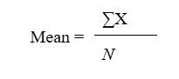
To generate the descriptive interpretation for each item and characteristic, the researchers will compute the mean using the standard formula:
Where: ΣX = total of all respondents’ ratings for a particular item
N = total number of respondents
The resulting mean value will then be compared with the mean range to determine the descriptive rating (e.g., Agree, Strongly Agree).

Chapter IV
TECHNICAL BACKGROUND
4.1 Introduction
This chapter provides a detailed technical overview of the technologies, frameworks, and system architectures employed in the development of "AGRI-AKAP: Agricultural Assistance and Knowledge Access Portal for Managing Farmers' Subsidies and Support Programs in the Municipal Agriculture Office". It establishes the rationale for selecting specific development tools and illustrates how these components interact to address the operational challenges of the Municipal Agriculture Office (MAO) of Echague. By outlining the system architecture and design considerations, this section provides a technical foundation for the project's implementation and testing phases.
4.2 System Architecture
4.2.1 Overview of System Architecture
The system follows a Three-Tier Client-Server architecture designed to manage the hybrid demands of office-based administration and disconnected field operations. This structure organizes the system into specialized layers: the Presentation Layer (Ionic), the Application Logic Layer (Laravel), and the Data Storage Layer (MariaDB), ensuring that each component is managed independently for better reliability.
4.2.2 System Components
- User Interface / Client Applications: The system utilizes a unified cross-platform application built with the Ionic Framework. This application serves as the Web Dashboard for MAO administrators and, via Capacitor, as the Mobile Application for field technicians to perform QR code scanning and distribution logging.
- Backend Server / Business Logic: The backend, powered by the Laravel framework, serves as the system's central brain. It processes all business logic, such as validating farmer eligibility, enforcing rules to prevent "double-claiming" of subsidies, managing the synchronization queue for offline field data, and staging automated weather advisories for mandatory administrative review.
- Database / Data Storage: The system employs a dual-layered storage strategy comprising a centralized MariaDB database for municipal-level records and a local IndexedDB instance within the Ionic PWA for offline resilience. This architecture allows field technicians to log distribution data in "dead spots" by staging records locally; once a stable internet connection is detected, a synchronization engine pushes the queued data to the Laravel API for validation and permanent storage in the central MariaDB repository, ensuring data integrity across all operational environments.
- External APIs / Integrations: The system integrates third-party services to enhance its monitoring and communication capabilities. This includes Google Maps for spatial data mapping, Open-Meteo for real-time and forecast climate monitoring, and the Semaphore API for automated SMS notifications. To ensure data credibility, climate data pulled from the Open-Meteo API generates prescriptive recommendations that are strictly held in a verification queue; these recommendations require manual validation by MAO experts before the server triggers the Semaphore API for SMS dissemination.
- Communication Protocols: Data exchange is conducted via HTTPS using a REST (Representational State Transfer) architectural style, with JSON as the primary data format.
4.2.3 System Architecture Diagram
The system adopts a specialized Three-Tier Architecture to facilitate a clear separation of concerns between user interaction, system processing, and persistent storage.
Figure 2
AGRI-AKAP Three-Tier System Architecture Diagram
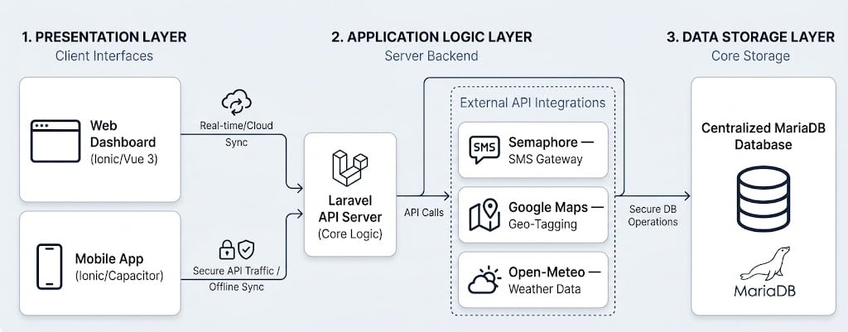
The architectural framework of the AGRI-AKAP system follows a specialized Three-Tier Client-Server model that separates user interaction, application logic, and data persistence. The Presentation Layer, serving as the primary client interface, acts as the visual touchpoint for all system stakeholders. Developed using the Ionic Framework, this tier provides a unified, cross-platform experience that includes a responsive web dashboard for office-based administrators and a native-capable mobile application for field technicians. By leveraging Capacitor, the mobile component gains direct access to native hardware, enabling critical features such as real-time QR code verification for secure field distributions.
Acting as the system’s central brain, the Application Logic Layer utilizes a Laravel API Server to orchestrate all critical functional processing. This middle tier is responsible for enforcing rigorous business logic, such as validating farmer eligibility and executing protocols designed to mitigate the risk of subsidy double-claiming. Beyond internal processing, the server functions as a secure gateway for external service integrations; it interfaces with Google Maps for geospatial mapping and the Semaphore SMS Gateway to broadcast automated agricultural advisories and announcements directly to farmers’ mobile devices.
At the foundation of the architecture, the Data Storage Layer guarantees the long-term integrity, security, and availability of all recorded information. This tier utilizes a centralized MariaDB database to manage the comprehensive RSBSA farmer registry, resource inventory levels, distribution transaction logs, and detailed system audit trails. To ensure seamless operation across these three tiers, communication is standardized via secure RESTful APIs over HTTPS. Data is transmitted exclusively in JSON format to optimize synchronization speed and maintain high reliability between the centralized office environment and remote field operations.
4.3 Technologies and Development Tools
4.3.1 Programming Languages
- PHP: The primary server-side language used for building robust APIs and core business logic within the Laravel framework.
- TypeScript: The primary language used within the Ionic Framework to build scalable, maintainable application logic. It provides static typing and advanced features that improve code quality and developer productivity.
- JavaScript: The fundamental scripting language that enables interactive elements and ensures the application runs seamlessly across all modern web browsers and mobile web views.
4.3.2 Frontend Frameworks
- Ionic Framework (with Vue 3 and Capacitor): This framework enables a single codebase to be deployed as both a web and a mobile application. Vue 3 handles reactive UI components, while Capacitor provides access to native mobile hardware, such as the camera, for QR code validation.
4.3.3 Backend Framework
- Laravel: Chosen for its performance, scalability, and built-in security features, such as secure authentication and protection against common web vulnerabilities.
4.3.4 Database Management System
- MariaDB: An open-source relational database used for the central server to provide ACID-compliant transactions, ensuring that bulk offline syncs do not lead to data corruption or "double-claiming" of subsidies.
4.3.5 Development and Collaboration Tools
- Visual Studio Code: The primary Integrated Development Environment (IDE) used for writing and debugging the codebase.
- Android Studio: Served as the essential Integrated Development Environment (IDE) for the native Android platform, bridging the Ionic/Capacitor web assets into a native mobile environment.
- Git and GitHub: Employed for version control and collaborative development, allowing for iterative code updates and secure repository management.
- Postman: Used for testing and documenting the API endpoints to ensure seamless communication between the mobile app and the server.
4.3.6 Hosting / Deployment Platform
- Railway: A cloud-based platform-as-a-service (PaaS) used to host the Laravel backend API and MariaDB database. It integrates directly with GitHub for automatic deployments, manages environment variables, and provides HTTPS—requiring no manual server configuration.
- Vercel: Functions as the primary hosting and deployment platform for the web-based version of the system. Utilizing the ionic build process, the application is deployed as a high-performance static site served via Vercel's global Edge Network. This ensures that the Progressive Web App (PWA) remains highly responsive across all mobile and desktop browsers.
- Google Play Store: The primary distribution channel for the system's native Android version. For centralized version management and secure mobile device installation, the Capacitor cross-platform bridge packages the frontend codebase as a native Android App Bundle (.aab).
- GitHub Actions (CI/CD Deployment Platform): Automates the build and deployment pipeline by triggering workflows on every code push to the repository. It automatically runs tests, builds the app, and sends the most recent stable version to Railway (backend) and Vercel (frontend). This ensures the release process remains the same and dependable throughout the full development cycle.
4.4 Design Considerations
4.4.1 Scalability The system is designed with a modular architecture to allow for future expansion, such as adding new types of agricultural resources or increasing the number of supported barangays without degrading performance.
4.4.2 Security To protect sensitive farmer data, the system implements secure authentication, AES-256 encryption for QR code metadata, and role-based access control (RBAC) to ensure only authorized personnel can approve resource releases.
4.4.3 Usability Following a user-centric design approach, the interfaces are tailored for non-technical field workers, utilizing simple icons, localized language support, and a streamlined scanning process.
4.4.4 Performance Efficiency The system is designed to provide rapid response times and maintain high throughput, even during peak distribution periods.
- Network Infrastructure and Bandwidth Allocation: A hybrid cloud strategy powers the system's network infrastructure, optimizing performance by separating frontend and backend environments. By deploying the Administrative Portal and Mobile PWA on Vercel, the system leverages a Global Edge Network that caches assets at points of presence closest to the user, significantly reducing latency and ensuring a responsive experience even on standard municipal bandwidth. The backend logic and MariaDB database are hosted on Railway's high-performance containerized infrastructure. This allows quick connectivity to other parts of the network and the allocation of resources as needed. This design eliminates fixed-bandwidth subscriptions in favor of a model that can scale and focuses on making the most of CPU and RAM. This lets the Laravel-based API handle high throughput and low latency, even when multiple field technicians are syncing data simultaneously, which is when distribution is at its busiest.
- Asset and UI Optimization: Following professional web standards, the administrative portal utilizes a "minimalist asset" approach. The design puts CSS-based styling and scalable vector graphics (SVGs) ahead of heavy, high-resolution images. By minimizing image data across the dashboard and registry modules, the system significantly reduces the "Time to First Byte" (TTFB). It ensures that pages remain lightweight and responsive, even on standard municipal internet connections.
- Distributed Processing via Offline-First Strategy: Field-level efficiency is maintained by offloading primary data processing to the mobile device's local environment. By utilizing an offline-first strategy, the system eliminates the need for a constant round-trip to the server for every transaction. Data is staged in the local IndexedDB and synchronized in bulk only after a stable connection is verified, effectively reducing server load during peak operating hours.
- Database Query Optimization: The MariaDB backend utilizes structured indexing and relational constraints to ensure that search queries—such as those used in the Advanced Analytics Hub—are executed with minimal CPU overhead. This prevents system "hangs" when generating complex diagnostic or predictive reports from large datasets.
4.5 User Interface Design (Mock-ups)
The User Interface (UI) design section presents the visual representation of the system's primary touchpoints for both administrative and field-based users. These mock-ups serve as a fundamental technical blueprint for the development phase, ensuring that the system's layout, navigation, and functional elements are strictly aligned with the operational requirements of the Municipal Agriculture Office (MAO). By defining the interface before implementation, the project ensures that the resulting applications are intuitive and accessible and provide a seamless experience across different hardware platforms.
4.5.1 Web Application Mock-ups
Figure 3
Secure Administrative Entry (Login)
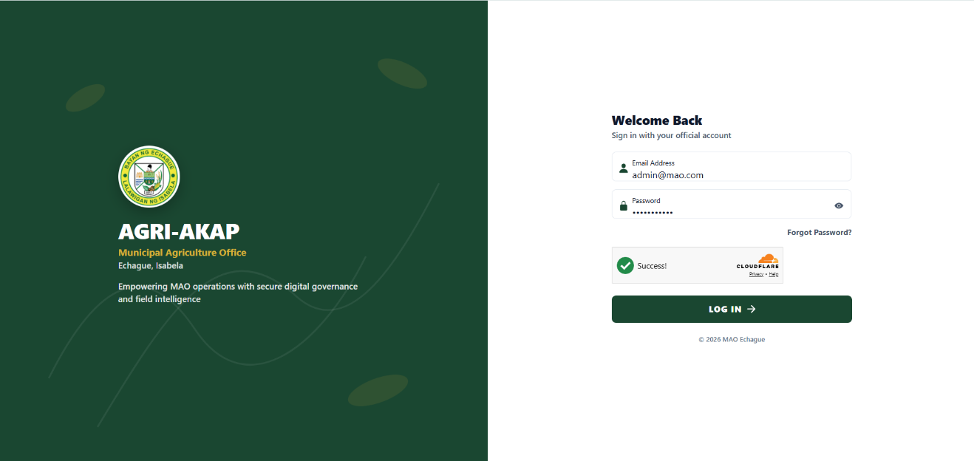

Figure 3 illustrates the secure entry point of the AGRI-AKAP system. This interface constitutes the primary authentication layer for MAO administrators, office staff, barangay agricultural workers, and field technicians, requiring unique credentials before any municipal agricultural record may be accessed. The design foregrounds institutional branding and a professional login card, establishing trust and role-based session initiation prior to entry into sensitive subsidy, farmer registry, and operational modules.
Figure 4
Analytics Dashboard
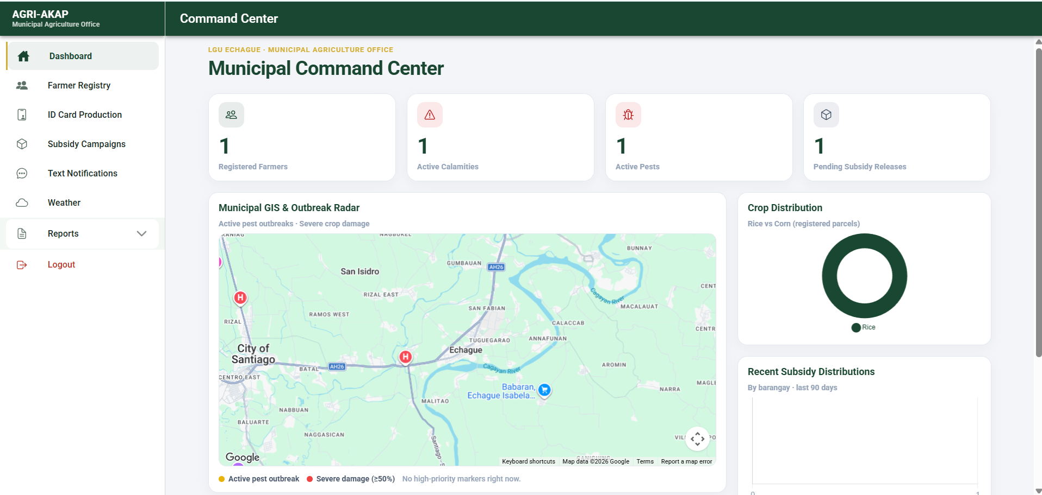
Figure 4 presents the Municipal Command Center, which consolidates analytics for executive oversight by the Municipal Agriculturist and MAO staff. The KPI strip quantifies registry scale, calamity and pest pressure, and pending subsidy releases, while the GIS outbreak radar spatially situates high-priority pest and damage markers across Echague. Complementary charts and the prescriptive alert panel enable data-driven decisions and immediate SMS advisory escalation, aligning municipal monitoring with rapid field response.
Figure 5
Farmer Registry Management (RSBSA Ledger)
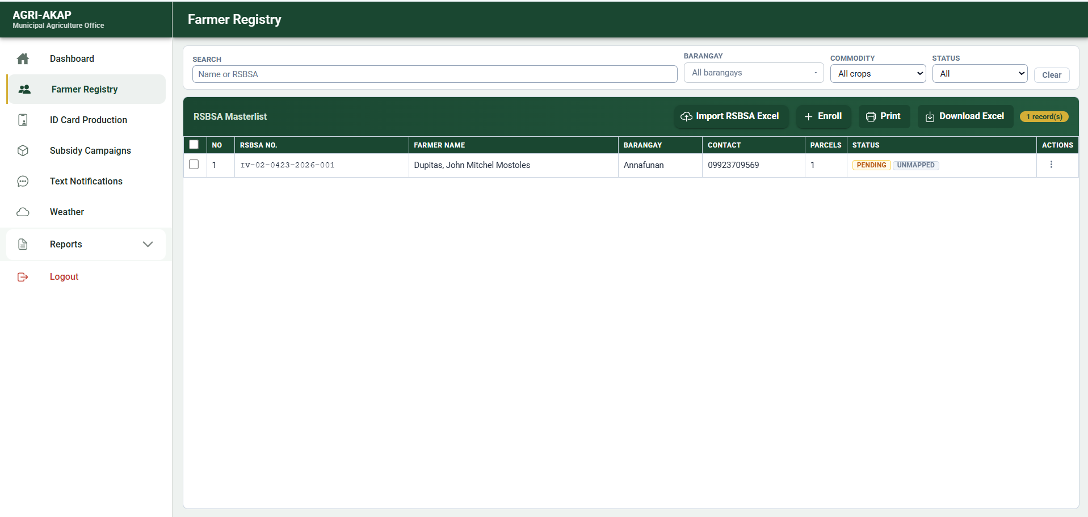
Figure 5 depicts the centralized RSBSA farmer registry maintained by the MAO. The high-density ledger supports search, barangay and commodity filtering, Excel import, and dossier-based profile review, parcel inspection, and verification actions.
Figure 6
Subsidy Program Management & Auto-Masterlisting
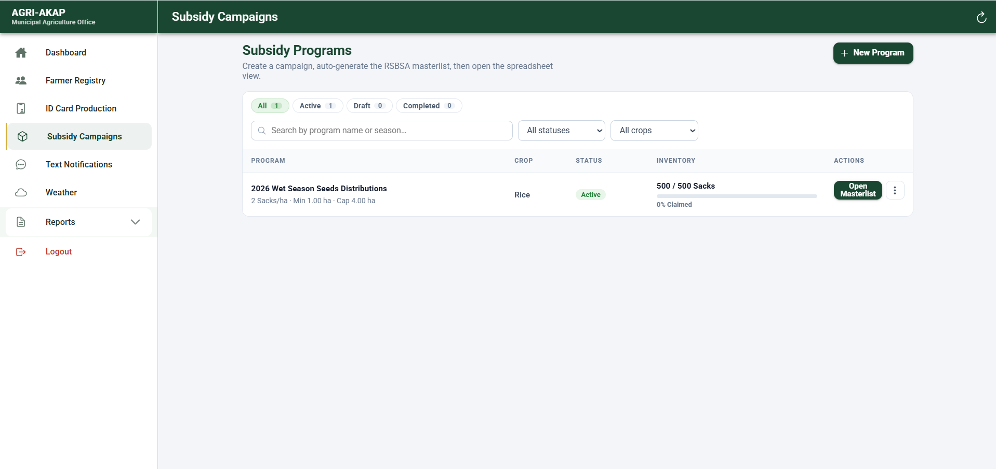
Figure 6 illustrates subsidy campaign administration and automated beneficiary masterlisting. From the subsidies workspace, MAO staff define and manage programs; the masterlist view then presents a spreadsheet-style grid of eligible farmers with calculated allocations, hectare caps, and visual progress on claims and warehouse stock. This design supports transparent, rules-based distribution planning and reduces manual listing errors during municipal subsidy operations.
Figure 7
ID Issuance Portal & QR Generator
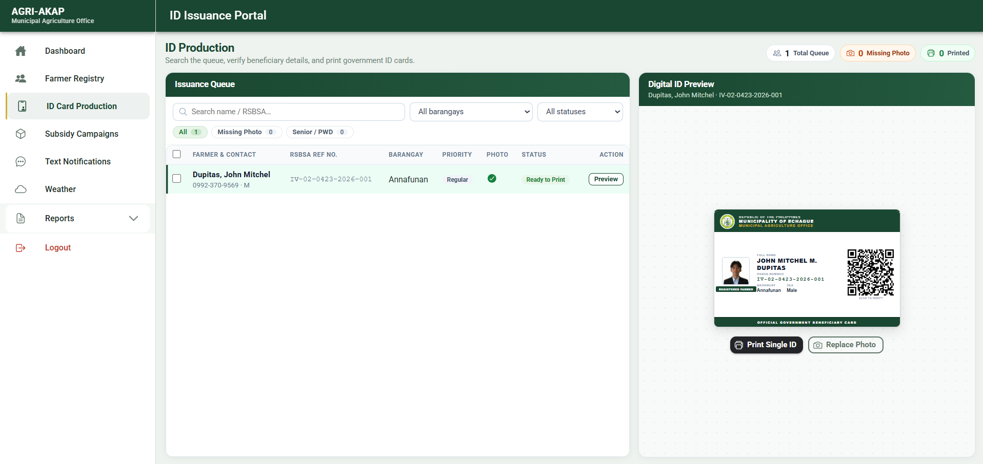
Figure 7 presents the farmer ID issuance portal used by the MAO to produce machine-readable beneficiary credentials. The dual-pane layout pairs queue management—including Senior and PWD priority banding—with a live printable ID preview containing a QR code for field scanning. This interface bridges registry verification and field dispensation, enabling technicians to authenticate farmers rapidly during subsidy release and georeferencing activities.

Figure 8
SMS Broadcast Center
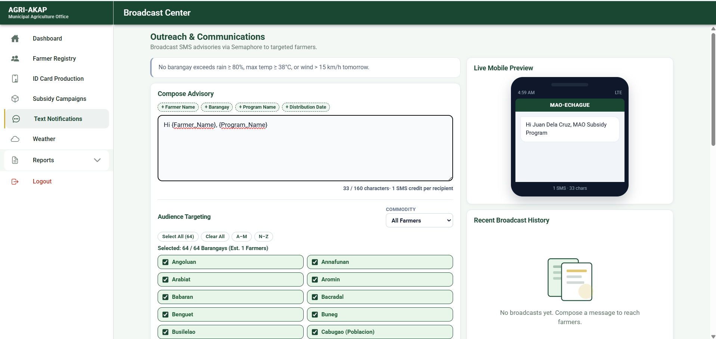
Figure 8 shows the municipal SMS broadcast center for targeted farmer advisories. MAO communicators compose messages, constrain audiences by crop commodity and selected barangays, and preview SMS segment cost before dispatch.
Figure 9
Disaster Damage Validation & Support Masterlist
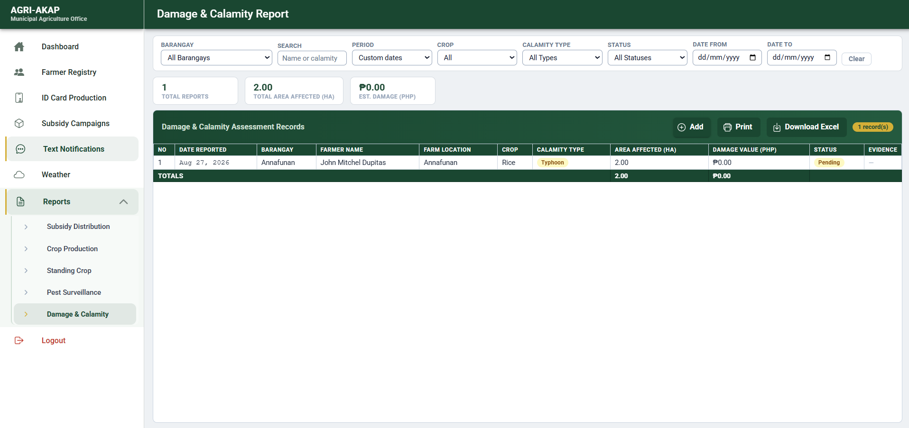
Figure 9 presents the damage and calamity reporting suite used to review technician- and barangay-submitted loss assessments. The interface consolidates calamity type and status filters, statistical summaries, and geotagged photo evidence in modal and print-annex forms. By enabling validation-oriented review of field-submitted damage records, the module supports RDANA-aligned rehabilitation planning and subsequent support masterlisting for seed and fertilizer buffer allocation.
Figure 10
Executive Reporting Suite (Statutory Accomplishment Export)
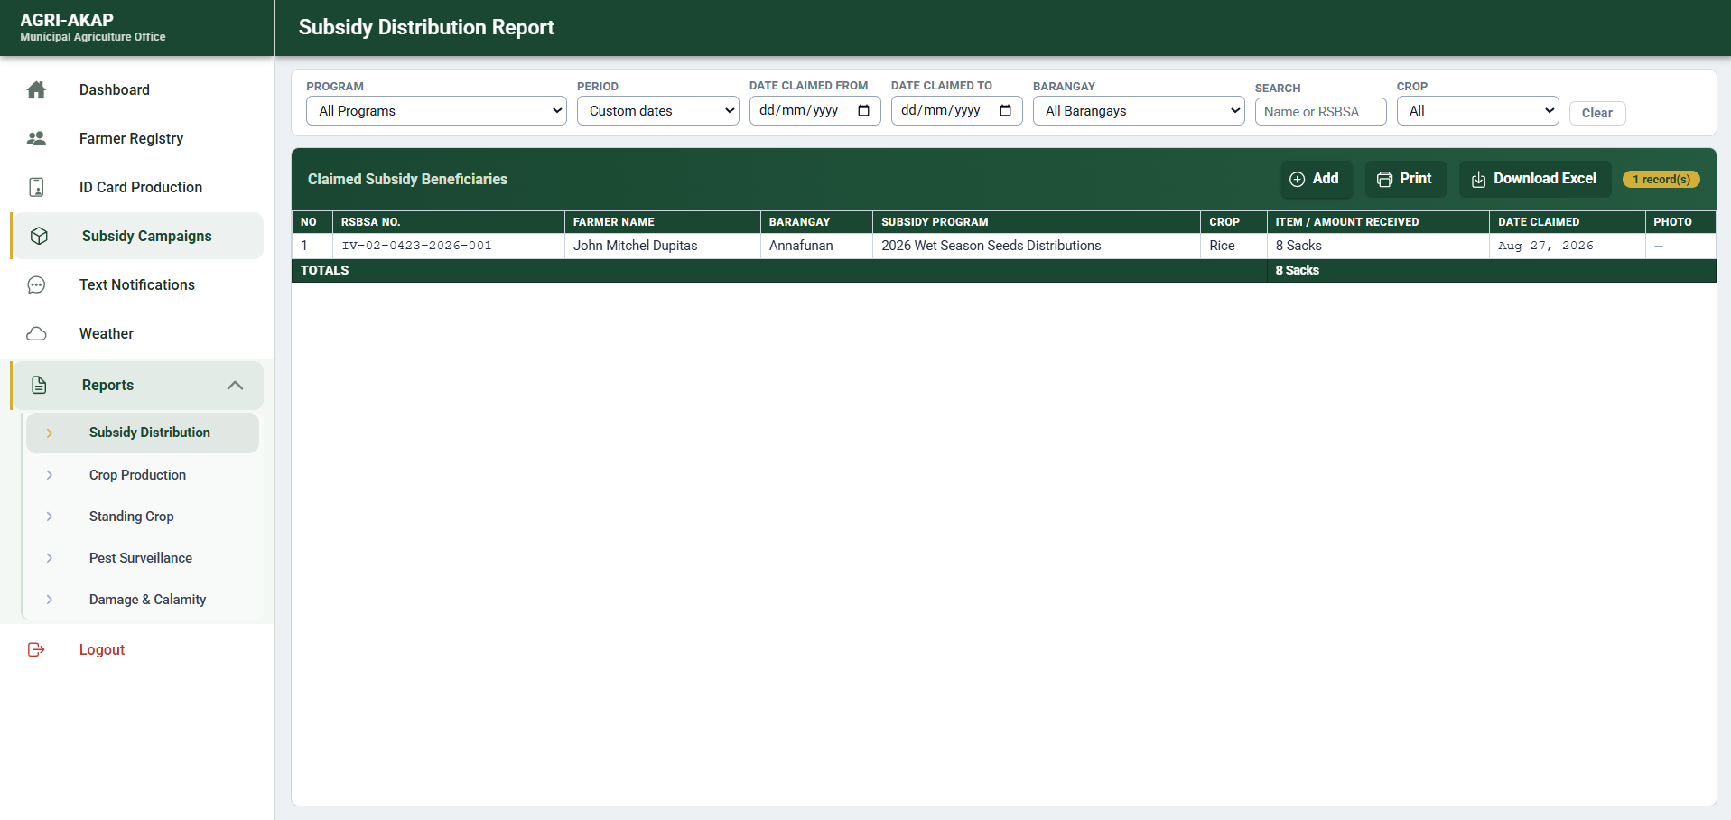
Figure 10 illustrates the executive reporting suite that generates statutory and operational accomplishment outputs for the MAO. Nested report modules for subsidy distribution, crop production, pest surveillance, and damage/calamity provide filterable grids with print preview and spreadsheet export. This design aligns digital records with LGU reporting obligations, enabling the Municipal Agriculturist to produce auditable, print-ready annexes without re-encoding field data.

Figure 11
Barangay Data Encoding Portal (Planted & Growing Crops)
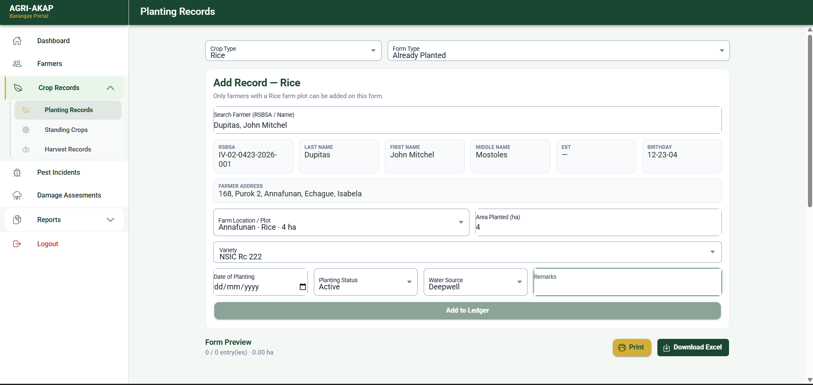
Figure 11 presents the barangay planting ledger, a simplified encoding portal for barangay agricultural workers. The interface prioritizes farmer search, crop and plot metadata, and hectarage logging over dense administrative grids, enabling frontline encoding of planted and growing crops at the barangay level. Captured records feed municipal production reporting and standing-crop monitoring, closing the information gap between field conditions and the MAO command center.

4.5.2 Mobile Application Mock-ups
Figure 12
Mobile Technician Entry
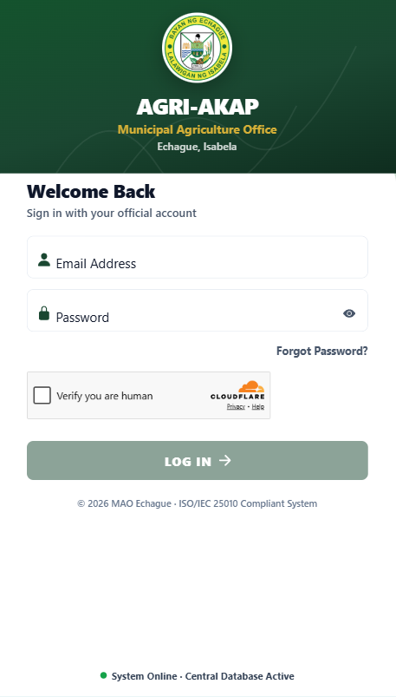
Figure 12 illustrates mobile authentication and the technician network status indicator essential for field operations in Echague. Technicians authenticate through the shared secure login and land on a one-handed mobile shell with a persistent Online/Offline badge.
Figure 13
Action-Oriented Mobile Dashboard
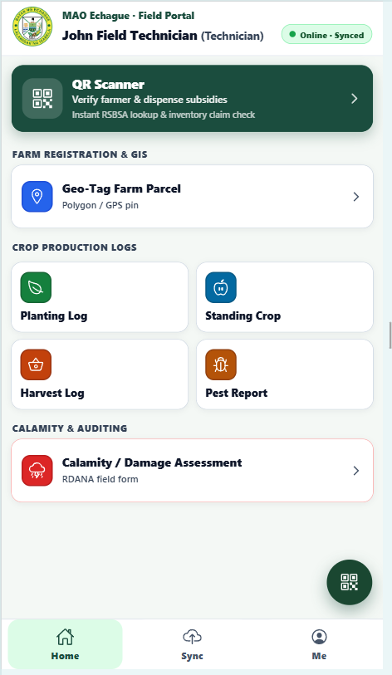
Figure 13 presents the technician home dashboard designed around scan-first subsidy and identity workflows. The hero “Scan Farmer ID” control elevates the most frequent field task, while the Field Toolkit provides rapid entry to pest, damage, geo-tag, planting, harvest, and standing-crop modules.
Figure 14
Mobile QR Subsidy Dispensation
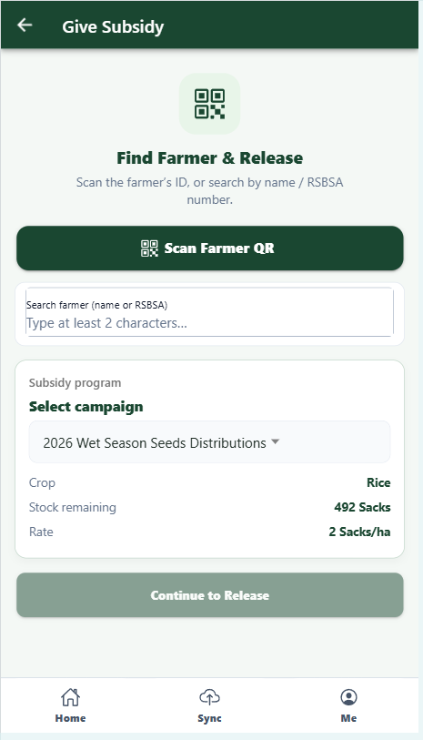
Figure 14 illustrates mobile QR-assisted subsidy dispensation for field technicians. The interface combines barcode/QR scanning with fallback name or RSBSA search, then binds the verified farmer to an active subsidy campaign and calculated allocation. Real-time identity resolution against the municipal registry supports transparent, accountable release of inputs at distribution points, including offline-queue persistence when connectivity is unavailable.
Figure 15
Pest & Disease Response Form
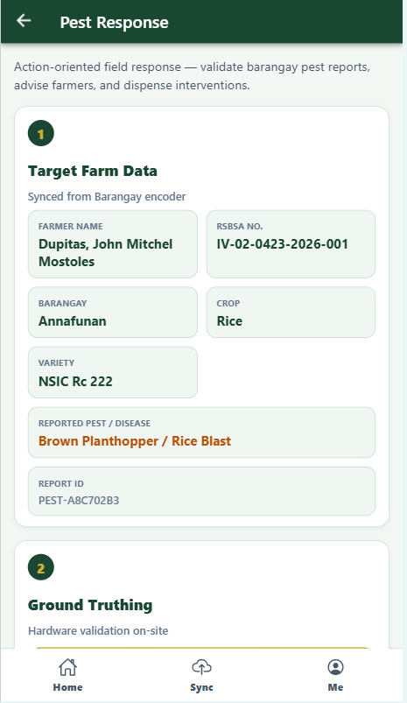
Figure 15 presents the pest and disease response form used for field ground-truthing of barangay-reported pest incidents. Technicians capture photo evidence, lock GPS coordinates, quantify incidence via a percentage control, classify severity, and optionally escalate an outbreak flag. These structured observations feed the municipal GIS outbreak radar and pest surveillance reports, enabling the MAO to prioritize advisory broadcasts and technical interventions.
Figure 18
Calamity Damage Assessment (RDANA)
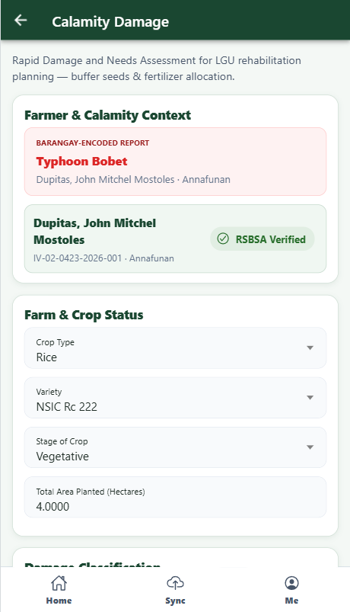
Figure 18 depicts the Rapid Damage and Needs Assessment (RDANA) mobile form for calamity-affected farms. The interface gathers calamity and farmer context, crop status and estimated loss parameters, GPS lock, and geotagged photographic proof.

Figure 19
GPS Farm Boundary Mapping & Soil Profiling
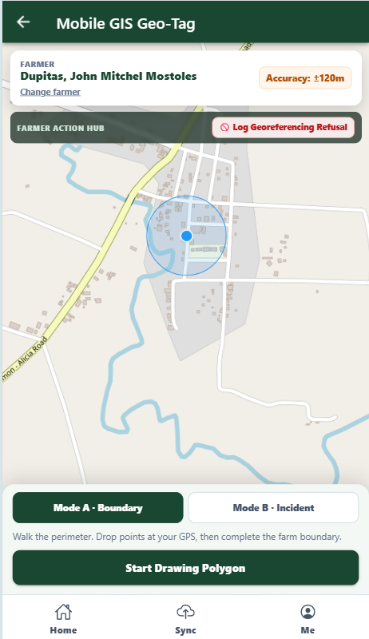
Figure 19 illustrates mobile GIS farm boundary mapping and georeferencing consent capture. Admin assign a technicians, walk the parcel perimeter while dropping GPS polygon points on a map, and complete dual digital signatures for DA-RSBSA georeferencing consent and validation.
Figure 20
Offline Queue & Bulk Sync Management
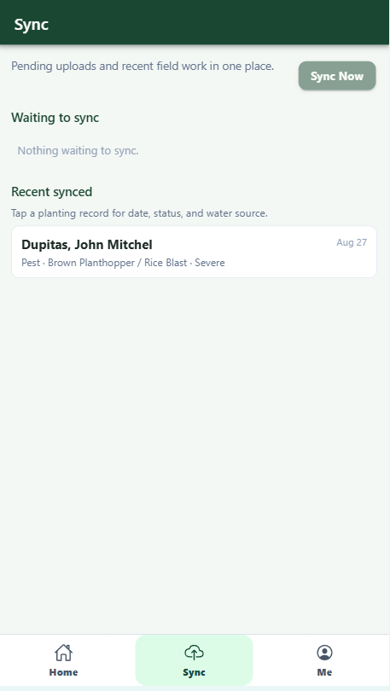
Figure 20 presents the offline queue and bulk synchronization manager for field operations under intermittent connectivity. Pending transactions—distributions, encodings, and related field records—are retained on-device and listed for review until Sync Now uploads them to the municipal cloud when online. This design ensures that subsidy releases and agronomic encodings performed in remote barangays are not lost, preserving continuity between technician fieldwork and MAO office systems.
4.6 System Diagrams
This section illustrates the logical and structural design of the AGRI-AKAP system through various architectural diagrams. These diagrams define the flow of information between external entities and internal processes, as well as the underlying data relationships.
4.6.1 Context Diagram
Figure 21
Context Diagram (Level 0) of the AGRI-AKAP System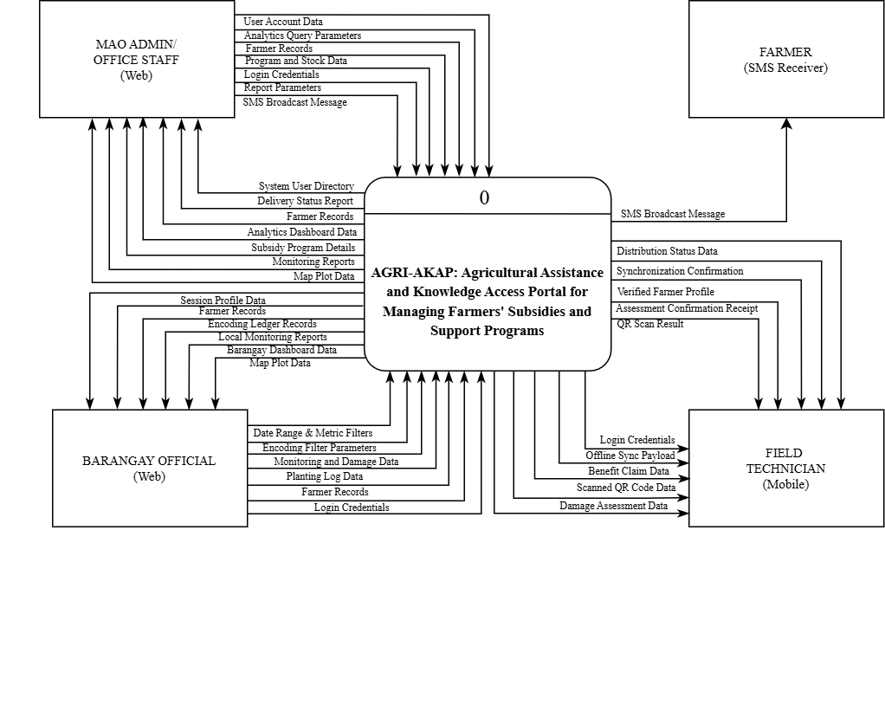
Figure 21 illustrates the Context Diagram of the AGRI-AKAP system, establishing the macro-level data exchanges between the central platform and its core external entities: the MAO Administrator, Barangay Official, Field Technician, and Farmer. The administrators and officials manage system parameters and registries via a web interface, while field technicians utilize a mobile application to synchronize offline payloads and submit field data. Ultimately, the system processes these inputs to facilitate direct communication with farmers by pushing SMS broadcast messages regarding advisories and program.
4.6.2 Data Flow Diagram (DFD)
Figure 22
Data Flow Diagram Level 1- Administrator
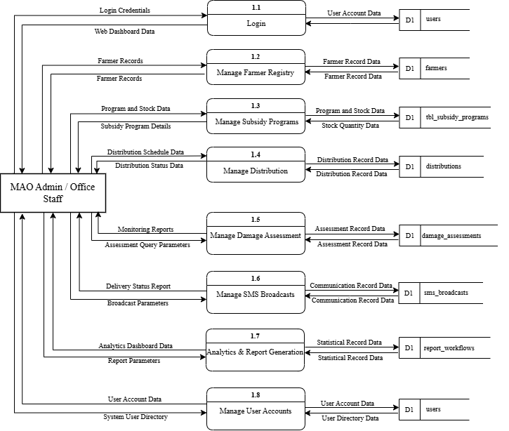
Figure 22 outlines the core sub-processes required for central system management and oversight. It details the specific pathways for handling farmer registries, subsidy programs, distributions, and damage assessments, routing strict noun-based data inputs into designated database tables. Additionally, it illustrates the data extraction flows necessary for the generation of analytical reports and SMS broadcasts based on the aggregated system records.
Figure 23
Data Flow Diagram Level 2 - Field Technician
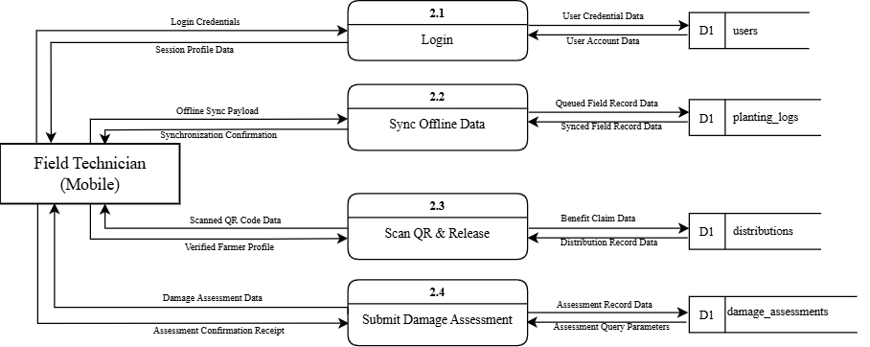
Figure 23 illustrates the mobile-driven processes utilized during on-the-ground agricultural operations. It diagrams the specific data transactions essential for synchronizing offline payloads, executing QR-based subsidy releases, and submitting damage assessment data to the system's databases. These pathways ensure that field-level inputs seamlessly update the central repository and generate immediate synchronization and confirmation receipts for the technician.

Figure 24
Data Flow Diagram Level 2 - Barangay Secretary
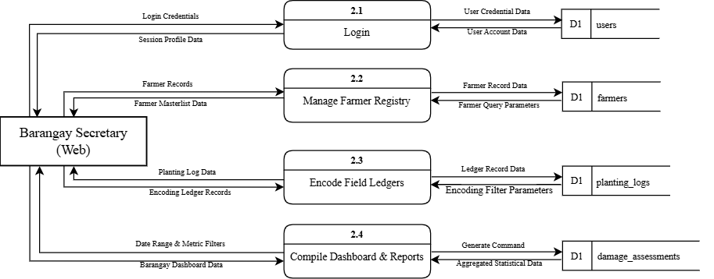
Figure 24 details the localized, web-based interactions permitted within the AGRI-AKAP architecture. This diagram maps the specific data flows for managing farmer masterlists, encoding field ledgers, and compiling local dashboard reports. By isolating these sub-processes, it defines exactly how community-level data parameters are inputted into and retrieved from targeted data stores to support localized administrative functions.
Figure 25
Data Flow Diagram Level 2 - Farmer
Figure 25 illustrates the streamlined, unidirectional communication process of the platform. It delineates how communication data query parameters extract relevant records directly from the SMS broadcast data store. This internal querying process culminates in the automated delivery of SMS broadcast messages out to the farmer's mobile receiver.

4.6.3 Entity Relationship Diagram (ERD)
Figure 26
Entity Relationship Diagram of the AGRI-AKAP System
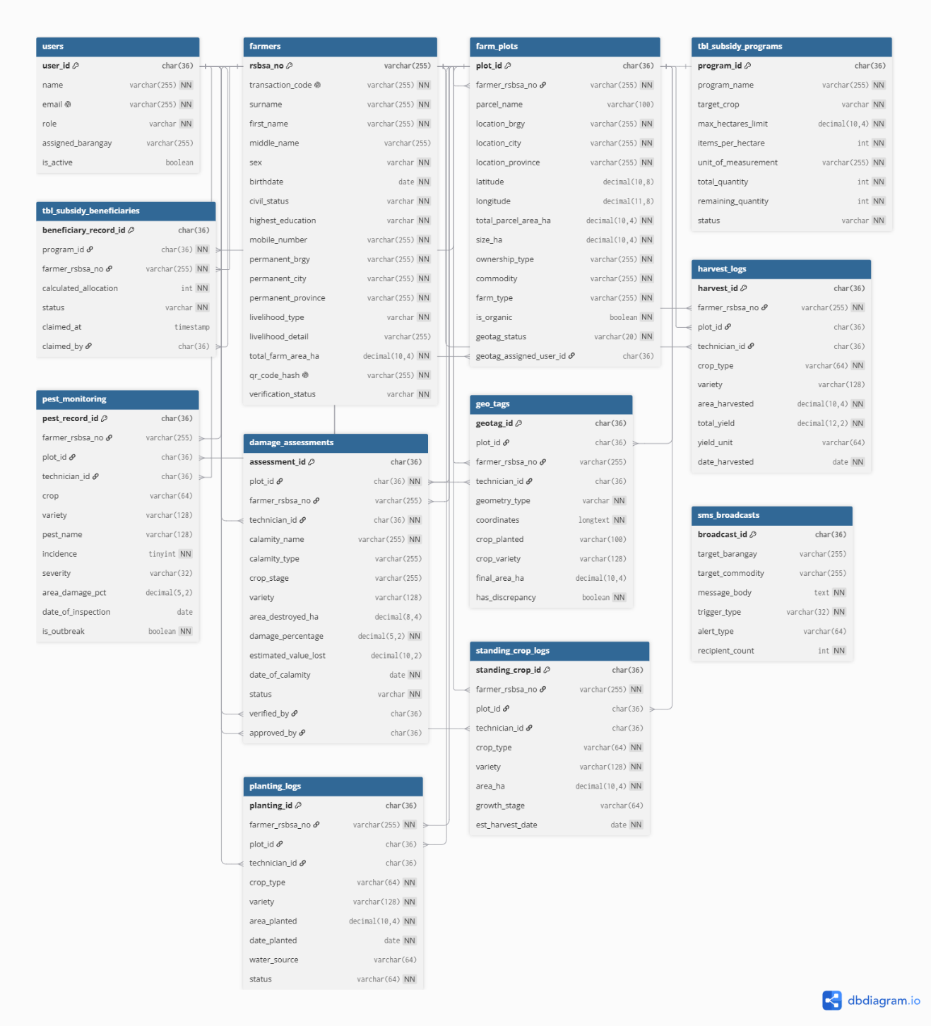

Figure 26 illustrates the Entity Relationship Diagram (ERD) of the system, defining the normalized relational data structure designed to support the portal’s administrative, field operations, and statutory reporting workflows. Organized into 12 specialized tables, the database enforces strict referential integrity across the entire agricultural management lifecycle. System access is governed by the users table, which manages role-based access control across administrators, field technicians, and barangay officials, maintaining authentication credentials, operational statuses, and assigned barangay boundaries.
The core of the database is established upon the farmers table, an RSBSA-compliant registry capturing personal demographics, educational attainment, civil status, and livelihood types. Each registered farmer is assigned a unique RSBSA number, transaction code, verification status, and a qr_code_hash for secure, rapid identity verification. This entity maintains a one-to-many relationship with farm_plots, which records parcel-level metadata including land ownership type, primary commodity, declared size, and geotag status. Precise spatial boundaries are recorded in the geo_tags table, which stores polygon or marker coordinate strings, computed final areas, and discrepancy flags (has_discrepancy) to eliminate parcel overlap and fraudulent land claims.
Field-level crop production and surveillance are structured across modular tracking logs. The planting_logs table records planting schedules, crop varieties, and water source types, while the standing_crop_logs table monitors active growth stages and projected harvest dates. Upon harvest, the harvest_logs table quantifies the harvested area and total crop yield to establish baseline municipal production data. For agricultural protection and emergency response, the pest_monitoring table logs pest sightings, incidence severity, and outbreak indicators (is_outbreak), whereas the damage_assessments table documents post-calamity crop and monetary losses through a hierarchical verification workflow involving technicians, verifiers, and approvers.
Finally, the transactional lifecycle of agricultural aid is managed by tbl_subsidy_programs and tbl_subsidy_beneficiaries, which define maximum hectare limits, input allocation rules, and live inventory tracking (total_quantity versus remaining_quantity) linked directly to RSBSA identifiers to prevent double-claiming. Municipal outreach and advisory dispatches are recorded in sms_broadcasts, which logs targeted communication dispatches filtered by barangay and commodity.

References
Alqoud, A., Milisavljevic-Syed, J., & Salonitis, K. (2025). Self-Assessment Model for Digital Retrofitting of Legacy Manufacturing Systems in the Context of Industry 4.0. International Journal of Industrial Engineering and Management. https://doi.org/10.24867/ijiem-391.
Alsuhibany, S. (2025). Innovative QR Code System for Tamper-Proof Generation and Fraud-Resistant Verification. Sensors (Basel, Switzerland), 25. https://doi.org/10.3390/s25133855.
Anguri, C., & Anthati, N. (2026). AgroSphere: Smart Agriculture and Transparent Marketplace. International Journal on Science and Technology. https://doi.org/10.71097/ijsat.v17.i2.11031
Ameh, S. S., Emmanuel, N. O., & Mbong, K. A. (2025). Impact of SMS-Based Agricultural Information Systems on Crop Management Skills Among Farmers in South Eastern Nigeria: A Quasi-Experimental Study. https://socialdigitalmediadiscourse.com/wp-content/uploads/2025/07/3.-Impact-of-SMS-Based-Agricultural.pdf
Aris, N. (2024). Design and Development Research (DDR) Approach in Designing Design Thinking Chemistry Module to Empower Students' Innovation Competencies. Journal of Advanced Research in Applied Sciences and Engineering Technology. https://doi.org/10.37934/araset.44.1.5568.
Association of Southeast Asian Nations. (2023, September 5). ASEAN leaders' declaration on strengthening food security and nutrition in response to crises. https://asean.org/wp-content/uploads/2023/09/ASEAN-Declaration-on-Strengthening-Food-Security.pdf
Avanidou, K., Alexandridis, T., Kavroudakis, D., & Kizos, T. (2023). Development of a multi scale interactive web-GIS system to monitor farming practices: a case study in Lemnos Island, Greece. Smart Agricultural Technology. https://doi.org/10.1016/j.atech.2023.100313.
Bahn, R. A., Yehya, A. A. K., & Zurayk, R. (2021). Digitalization for sustainable agri-food systems: potential, status, and risks for the MENA region. Sustainability, 13(6), 3223. https://doi.org/10.3390/su13063223
Balaji, T., Hari, V., Lathifunnisa, S., Ganesh, P., & Arupya, P. (2024). Optimizing Web-based Inventory Management system using QR code Technology. 2024 7th International Conference on Circuit Power and Computing Technologies (ICCPCT), 1, 751-756. https://doi.org/10.1109/iccpct61902.2024.10673103.
Barletta, V., Caivano, D., Colizzi, L., Dimauro, G., & Piattini, M. (2022). Clinical-chatbot AHP evaluation based on "quality in use" of ISO/IEC 25010. International journal of medical informatics, 170, 104951. https://doi.org/10.2139/ssrn.4041111
Basir, M., Buckmaster, D., Raturi, A., & Zhang, Y. (2024). From pen and paper to digital precision: a comprehensive review of on-farm recordkeeping. Precision Agriculture, 25, 2643 - 2682. https://doi.org/10.1007/s11119-024-10172-7
BenYishay, A., DiLorenzo, M., & Dolan, C. (2022). The economic efficiency of aid targeting. World Development, 160. https://doi.org/10.1016/j.worlddev.2022.106062
Bhandari, T. (2023). Assessment of Government Policies, Farm Subsidies, and Agriculture Growth. State, Society and Development: PMPD Perspectives. https://doi.org/10.3126/ssd.v1i1.58475
Briones, R. M., Galang, I. M. R., & Latigar, J. S. (2023). Transforming Philippine Agri-Food Systems with Digital Technology: Extent, Prospects, and Inclusiveness (No. 2023-29). PIDS Discussion Paper Series. https://hdl.handle.net/10419/284628
Choruma, D., Dirwai, T., Mutenje, M., Mustafa, M., Chimonyo, V., Jacobs-Mata, I., & Mabhaudhi, T. (2024). Digitalisation in agriculture: A scoping review of technologies in practice, challenges, and opportunities for smallholder farmers in sub-saharan africa. Journal of Agriculture and Food Research. https://doi.org/10.1016/j.jafr.2024.101286.
Crelin, J. (2022). Rapid application development (RAD). EBSCO Research Starters. https://www.ebsco.com/research-starters/computer-science/rapid-application-development-rad
Das, S., & Nayak, P. (2024). Integration of IoT- AI powered local weather forecasting: A Game-Changer for Agriculture. ArXiv, abs/2501.14754. https://doi.org/10.48550/arxiv.2501.14754
Duraimurugan, N., G, A., & S, A. (2025). Empowering Precision Agriculture: A Comprehensive Real-Time Monitoring and Decision Support System for Farmers. 2025 International Conference on Electronics and Renewable Systems (ICEARS), 1215-1222.
https://doi.org/10.1109/icears64219.2025.10940108
Estdale, J., & Georgiadou, E. (2018). Applying the ISO/IEC 25010 quality models to software product. In X. Larrucea et al. (Eds.), Systems, Software and Services Process Improvement (EuroSPI 2018) (pp. 492–503). Springer.
Fan, T., Feng, Q., Li, Y., Shanthikumar, J., & Wu, Y. (2023). Output-Oriented Agricultural Subsidy Design. Manag. Sci., 70, 1448-1464. https://doi.org/10.2139/ssrn.4378693
Firdaus, A. (2025). Web-Based Monitoring and Management System for Livestock Operations. Journal of Computer Science Application and Engineering (JOSAPEN). https://doi.org/10.70356/josapen.v3i2.69
Gonçalves, C., Fernandes, J., & Brites, C. (2025). Blockchain-Enabled Traceability in the Rice Supply Chain: Insights from the TRACE-RICE Project. Foods, 14. https://doi.org/10.3390/foods14213711.
González-Pérez, A., Matey-Sanz, M., Granell, C., Díaz-Sanahuja, L., Bretón-López, J., & Casteleyn, S. (2023). AwarNS: A framework for developing context-aware reactive mobile applications for health and mental health. Journal of Biomedical Informatics, 141, 104359. https://doi.org/10.1016/j.jbi.2023.104359
International Rice Research Institute. (2025, April 3). How can the rice crop manager reach more farmers? https://www.irri.org/news-and-events/news/how-can-rice-crop-manager-reach-more-farmers agricultural registry database
Jayashree, V., Asokhan, M., Nirmala, D. M., Padma, S., Pragadeesh, V., Anjugam, M., & Kokilavani, S. (2025). Weather based agro advisory services in promoting sustainable agriculture: A review. Plant Science Today. https://doi.org/10.14719/pst.7357
Jung, H. S., Lee, H., & Park, K. C. (2025). Analysis of UX Elements in Educational Applications for Young Children and Implementation of ISO/IEC 25010 Quality Standards. SAGE Open, 15(3), 21582440251377385. https://doi.org/10.1177/21582440251377385
K, M., Maiti, S., Garai, S., Reddy, D. A. K., Sahani, S., Panja, A., & Jha, S. K. (2024). Impact of climate services on the operational decision and economic outcome of wheat (Triticum aestivum) and rice (Oryza sativa) cultivation in Haryana. The Indian Journal of Agricultural Sciences. https://doi.org/10.56093/ijas.v94i3.148633
Kumar, R., Upadhyay, S., Ranawat, G., Kumar, B., Kumar, A., & Kumar, S. (2025). Raks. SK v1.0 - A Secure and Trackable QR Framework with Embedded Metadata and Real-Time Validation. 2025 5th International Conference on Intelligent Technologies (CONIT), 1-5. https://doi.org/10.1109/conit65521.2025.11166796.
Li, W., Dong, W., Zhang, X., & Zhang, J. (2023). A New Remote Sensing Service Mode for Agricultural Production and Management Based on Satellite–Air–Ground Spatiotemporal Monitoring. Agriculture, 13(11), 2063. https://doi.org/10.3390/agriculture13112063
Mappatao, D. G. M., De Silva, D. M., Lapitan, M. D., & De Leon, G. J. Development of a Database Management System for a Municipal Agriculture Office in the Philippines. https://doi.org/10.46254/AU04.20250116.
Mendes, J., Pinho, T. M., Neves dos Santos, F., Sousa, J. J., Peres, E., Boaventura
Cunha, J., Cunha, M., & Morais, R. (2020). Smartphone Applications
Targeting Precision Agriculture Practices—A Systematic
Review. Agronomy, 10(6), 855. https://doi.org/10.3390/agronomy10060855
Moumane, K., Idri, A., Aouni, F., Laghnimi, J., Benabdellah, N., & Hamal, O. (2024). ISO/IEC 25010-based Quality Evaluation of Three Mobile Applications for Reproductive Health Services in Morocco. Clinical and Experimental Obstetrics & Gynecology. https://doi.org/10.31083/j.ceog5104088
Muin, S., Rahim, M., Gunawan, G., & Khusna, D. (2025). Effectiveness of Government Services in Supporting Increased Agricultural Production. Journal of Management and Administration Provision. https://doi.org/10.55885/jmap.v5i2.642
Ozonze, O., Scott, P., & Hopgood, A. (2023). Automating Electronic Health Record Data Quality Assessment. Journal of Medical Systems, 47. https://doi.org/10.1007/s10916-022-01892-2
Palmares, S. C., & Cerna, P. D. (2025). Web-based geographic information systems for precision agriculture in sugarcane farming: A comprehensive review. International Journal of Multidisciplinary Research and Analysis, 8(3). https://doi.org/10.47191/ijmra/v8-i03-36
Papaskiri, T., & Lipski, S. (2023). Maintaining the register of agricultural lands as a real step towards the implementation of the data management function for these lands by the state. E3S Web of Conferences. https://doi.org/10.1051/e3sconf/202339504003
Potturu, S. M. (2023). Revolutionizing Field Data Collection and Management: The Role of PowerApps and RPA in Improving Service Quality, Enhancing Customer Experience, and Reducing Manual Effort. https://doi.org/10.11648/j.se.20231001.12
Purbaratri, W., Hartomo, K. D., & Tambotoh, J. J. (2023, December). The new smart government software quality framework uses modifications to iso/iec 25010. In 2023 Eighth International Conference on Informatics and Computing (ICIC) (pp. 1-6). IEEE. https://doi.org/10.1109/icic60109.2023.10382109
Rahaman, S., & Islam, M. (2025). ICT and food security nexus in the GCC region: exploring corruption control, FDI, and environmental sustainability dynamics. Discover Food, 5. https://doi.org/10.1007/s44187-025-00413-7
Schoormann, T., Möller, F., Kruse, L., & Otto, B. (2024). BAUSTEIN—A design tool for configuring and representing design research. Information Systems Journal, 34, 1871 - 1901. https://doi.org/10.1111/isj.12516
Sciullo, L., Montori, F., Zyrianoff, I., Gigli, L., Tinti, D., & Di Felice, M. (2023, June). Designing a hybrid push-pull architecture for mobile crowdsensing using the web of things. In 2023 IEEE International Conference on Smart Computing (SMARTCOMP) (pp. 332-337). IEEE. https://doi.org/10.1109/smartcomp58114.2023.00081
Silva, L., Soltovski, R., Pontes, J., Treinta, F., Leitão, P., Mosconi, E., Resende, L., & Yoshino, R. (2022). Human resources management 4.0: Literature review and trends. Comput. Ind. Eng., 168, 108111. https://doi.org/10.1016/j.cie.2022.108111
Storey, V., Baskerville, R., & Kaul, M. (2024). Reliability in design science research. Information Systems Journal, 35, 1014 - 984. https://doi.org/10.1111/isj.12564
Surachman, A. (2024). Optimasi Pengalaman Pengguna: Evaluasi ISO/IEC 25010 pada Penjualan Online. STRING (Satuan Tulisan Riset dan Inovasi Teknologi). https://doi.org/10.30998/string.v8i3.19324
Suryadi, D. A., & Sulistiyani, E. (2022). Evaluation of information quality using ISO/IEC 25010:2011 (Case research: Menu daily application). International Journal of Innovation in Enterprise System, 6(2), 143-156. https://doi.org/10.25124/ijies.v6i02.167
Teves, L. (2024). Smart Educational Resource Management: A QR Code-Enabled System with Notification and Alerting Capabilities. Journal of Innovative Technology Convergence. https://doi.org/10.69478/jitc2024v6n002a06.
Valdez, A. (2024). FACTORS AFFECTING THE INCOME OF RICE FARMERS OF THE BACDAFRANJOSE AGRARIAN REFORM COMMUNITY (ARC). International Journal of Arts, Sciences and Education, 5(3), 58-72.
Waluyo, T., Arvianti, E., & Santosa, B. (2025). The Impact of the Digitalization System for Subsidized Fertilizer Distribution on the Productivity of Rice Farmers in Malang Regency. Jurnal Dinamika Sosial Ekonomi. https://doi.org/10.31315/jdse.v26i1.14784.
Wang, Z., Han, D., & Hou, J. (2024, January). Design of dual code traceability system for agricultural products based on rsa algorithm. In 2024 Asia-Pacific Conference on Software Engineering, Social Network Analysis and Intelligent Computing (SSAIC) (pp. 83-88). IEEE. https://doi.org/10.1109/ssaic61213.2024.00022
White, M. (2022). Sample size in quantitative instrument validation studies: A systematic review of articles published in Scopus, 2021. Heliyon, 8. https://doi.org/10.1016/j.heliyon.2022.e12223
Yang, S.-H., Phan, H. T. T., Hsieh, C.-M., & Li, T.-N. (2022). What Intentions and Interesting Information Can Attract Consumers to Scan QR Code While Buying Eggs? Foods, 11(9), 1259. https://doi.org/10.3390/foods11091259
Zhang, T., Qiu, H., Castellano, G., Rifai, M., Chen, C., & Pianese, F. (2022). System Log Parsing: A Survey. IEEE Transactions on Knowledge and Data Engineering, 35, 8596-8614. https://doi.org/10.1109/tkde.2022.3222417

